

**Department of Biomedical Engineering**

**FYP595 Final Year Project**

**Spring 2024-2025**

**GBrain:** **A GRAPH SIGNAL PROCESSING APPROACH TO EEG BASED ATTENTION DETECTION**

|  |  |  |  |
| --- | --- | --- | --- |
|  | **Name** | **Email** | **Phone** |
| **Submitted by** | Sami Al Majanini | 201910088@st.cityu.edu.lb | 71 938 513 |
| **Supervisor** | Prof. Mohamad Khalil | mohamad.khalil@ul.edu.lb | 03396747 |
| **Co-Supervisor** | Dr. Aya Kabbara | [aya.kabbara@liu.edu.lb](mailto:aya.kabbara@liu.edu.lb) | 70149436 |
| **1st Examiner** | Dr. Firas Zakaria | f.zakaria@cityu.edu.lb | 70134416 |
| **2nd Examiner** | Dr. Ahmad Diab | ahmad.diab@liu.edu.lb | 03143647 |
| **Faculty Dean** | Dr. Hiba Al Sheikh | h.sheikh@cityu.edu.lb | 03171847 |

Rev1, Rev2, Rev3, Rev4, Rev5, Rev6, Rev7, Rev8, Rev9, Rev10, Rev11 2025/07/11

Abstract

Attention plays a vital role in learning, and EEG offers a non-invasive way to monitor attention-related brain activity. While existing methods rely on linear, frequency-domain, or nonlinear features extracted from individual electrodes, they often ignore inter-channel relationships and require high-density EEG systems. This study proposes a graph-based framework that captures both static and dynamic network features from four functional connectivity measures (COH, DPLI, MI, Pearson) using only 8 EEG channels.

Topological and pairwise connectivity analyses revealed that inattention was characterized by dense but locally clustered and inefficient connectivity, with increased mutual information and altered directional flows in fronto-central regions, suggesting a shift toward internally focused networks. In contrast, attention exhibited sparser but globally efficient networks, marked by stronger coherence optimized hub-mediated routing across task-relevant frontal areas, indicating enhanced long-range integration and top-down control. In classification, Logistic Regression and SGD reached 99.24% accuracy, F1 score 0.99 in the subject-dependent setting, and SVM achieved 83.91% accuracy, F1 score 0.84 in leave-one-subject-out evaluation outperforming state-of-the-art methods. These results demonstrate that graph-based EEG features are effective biomarkers of attentional states and support scalable, low-complexity attention monitoring systems.

***Keywords: Attention detection, EEG, Functional connectivity, Graph theory, Machine learning, Signal processing, Cognitive state classification.***Table of Contents

Abstract i

List of Figures iv

List of Tables vi

List of Abbreviations vii

Acknowledgements i

Chapter 1: General Introduction 1

1.1 Statement of the Problem 2

1.2 Purposes 2

1.3 Significance, Scope and Definitions 3

1.4 Thesis Outline 3

Chapter 2: Attention In Cognitive Neuroscience 1

2.1 Background 1

2.2 Brain Regions Associated with Attention 2

2.3 Factors Affecting Attention 3

2.4 Electroencephalography (EEG) 5

2.5 Approaches For Evaluating Attention In Cognitive Research and Practical Applications. 8

2.6 Conclusion 9

Chapter 3: LITERATURE REVIEW 11

3.1 Historical Background 11

3.2 Machine learning 11

3.3 EEG Functional Connectivity 12

3.4 Graph Theory in EEG Signal Analysis 13

3.5 State of the Art 14

3.6 Comparison and Conclusions 27

Chapter 4: METHODOLOGY 33

4.1 Research Design 33

4.2 Methodology Workflow 35

4.3 EEG Data Acquisition Protocol 36

4.4 EEG signal processing 38

4.5 Functional Connectivity Computation 40

4.6 Graph Theory and Functional Brain Network Construction 42

4.7 Feature Analysis Using Statistical Testing (t-test) 45

4.8 Classification Framework: Subject-Dependent and Subject-Independent Models 46

4.9 Conclusion 49

Chapter 5: Results and Discussions 51

5.1 Functional connectivity computation result 51

5.2 Feature Analysis Results 55

5.3 Classification Results 61

Chapter 6: Project Management 69

6.1 Gantt Chart 69

6.2 SWOT analysis 70

Chapter 7: Conclusions and Future Works 71

7.1 Summary of the Study 71

7.2 Conclusions 71

7.3 Limitations 72

7.4 Recommendations and Future Work 72

References 73

Appendices 79

List of Figures

Figure ‎2‑1:Neural correlates of attention in the brain[9]. 2

Figure ‎2‑2: The frontal lobe is by far the largest of the four lobes of the cerebrum and is responsible for many functions[10]. 3

Figure ‎2‑3: Sketch of how to record an Electroencephalogram[22]. 6

Figure ‎2‑4: The image illustrates the four primary types of brain wave frequencies commonly measured using EEG[27]. 7

Figure ‎3‑1:. Supervised learning is categorized to classification. And unsupervised learning is categorized to clustering and dimensionality[38]. 12

Figure ‎3‑2: Example coherence connectivity matrices. Color intensity indicates the strength of coherence between EEG electrode pairs. 13

Figure ‎3‑3: Brain network graphs representing functional connectivity patterns during Attention (left) and Inattention (right) cognitive states, both depicted at a density of 40%. 14

Figure ‎3‑4: Comparison of the highest correct classification rates on 3 and 5 classes with different K-values[39]. 15

Figure ‎3‑5: Scalp topological distributions of grand [42]. 17

Figure ‎3‑6: The 3-class classification results for dynamical parameters (left) and the 2-class classification (right) [45]. 19

Figure ‎3‑7: The architecture of discrete wavelet transforms (DWT) for extracting (EEG) features[48]. 21

Figure ‎3‑8: The flowchart of the employed GA-LIBSVM algorithm [48]. 21

Figre ‎3‑9: The flowchart of the proposed method. [54]. 23

Figure ‎3‑10: Marginal spectra of IMF2–5 when the representative participant was a paying attention and b taking a rest [54]. 23

Figure ‎3‑11: The HHT spectrum of the energy distribution. [54]. 24

Figure ‎3‑12: Attention paradigm protocol 25

Figure ‎3‑13: Average intra-subject accuracies using different types of features and different classifiers[56]. 26

Figure ‎3‑14: Average inter-subject accuracies using different types of features and different classifiers[56]. 26

Figure ‎4‑1:Overview of the EEG-based attention detection workflow. The process involves EEG acquisition, preprocessing, functional connectivity computation, graph construction, feature extraction using network measures, and classification based on extracted features. 36

Figure ‎4‑2: Block diagram of the proposed acquisition protocol 36

Figure ‎4‑3: A diagram of the 10-20 system for electrode placement for electroencephalography (EEG). 37

Figure ‎4‑4: Raw EEG signals recorded from 8 channels (Fp1, Fp2, Fz, F3, F4, C3, Cz, and C4) over a 5-second interval. 37

Figure ‎4‑5: Example of an independent component identified as an ocular artifact using ICA. The topographic map shows strong frontal activation consistent with eye blinks, and the time series illustrates its characteristic temporal pattern. 39

Figure ‎4‑6: Schematic diagram of signal segmentation 39

Figure ‎4‑11: Thresholded graph representation of Coherence connectivity for Attention (left) and Inattention (right). Edge thickness and colors represent connection strength. 43

Figure ‎5‑1:Average Pearson R Connectivity by ConditionHeatmaps illustrate average Pearson R values between EEG channels for (Left) Attention and (Right) Inattention. Warm (yellow) and cool (purple) colors denote positive and negative correlations, respectively. 52

Figure ‎5‑2: Average Coherence Connectivity Heatmaps display average coherence values for EEG electrode pairs during (Left) Attention and (Right) Inattention Conditions. Warmer colors (yellow) indicate higher synchronization, while cooler colors (purple) indicate lower synchronization. The diagonal represents self-coherence (1.0). 53

Figure ‎5‑3: Average dPLI Connectivity Across Conditions. Heatmaps show averaged Directed Phase Lag Index (dPLI) between EEG electrode pairs for Attention (left) and Inattention (right). Values from 0.4 to 0.6 indicate directionality: >0.5 means row leads column, <0.5 means column leads row. This reveals asymmetric, directed information flow. 54

Figure ‎5‑4: Average MI Connectivity Across Conditions. Heatmaps show averaged Mutual Information (MI) between EEG electrode pairs for Attention (left) and Inattention (right) conditions. Values (0.0-0.65) indicate shared information; higher values mean greater dependence. 55

Figure ‎5‑5:Coherence (COH) network features during attention (blue) and inattention (orange) states. Left Size of largest component ratio reflects network integration, with lower values indicating more fragmented organization. Right Global efficiency measures information transfer capacity, where higher values suggest more optimized routing. 57

Figure ‎5‑6:Directed Phase Lag Index (DPLI) network topology features. Left Betweenness centrality identifies hub regions critical for information flow. Middle Gini coefficient quantifies degree distribution equality (0=uniform, 1=unequal). Right Algebraic connectivity reflects network robustness. 58

Figure ‎5‑7:Mutual information (MI) network characteristics comparing cognitive states. Left Global efficiency captures nonlinear information integration capacity. Right Closeness centrality reveals nodes with shortest paths to others, indicating efficient communication hubs. 59

Figure ‎5‑8:Linear correlation (Pearson r) network properties. Left Global efficiency of linear connections forms the structural backbone. Right Closeness centrality of linearly correlated nodes shows stable hub architecture. 60

Figure ‎5‑9: Average Receiver Operating Characteristic (ROC) Curve for Each Model (LOSO Cross-Validation). This plot displays the mean true positive rate versus false positive rate for various classifiers, with the shaded regions indicating the standard deviation of ROC curves across individual subject folds, providing insight into model robustness and generalization capabilities. 65

Figure ‎5‑10: Radar plot showing average LOSO accuracy (%) for each classifier, illustrating model performance across subjects. 66

List of Tables

Table ‎3‑1: The inference of classification accuracy using various features [40]. 16

Table ‎3‑2: Results for attention recognition using holdout validation and the different classifiers SVM, RF, and KNN [43]. 18

Table ‎3‑3: The effect of the wavelet filter on the recognition accuracy [50]. 20

Table ‎3‑4: Comparative Table of Several attention detection studies using machine learning and Artificial Neural networks. 27

Table ‎3‑5: A summary of advantages of methodologies, and limitations of each study, highlighting the diversity of approaches and gaps in scalability, participant diversity, and real-world applicability. 30

Table ‎4‑1: Comparison of proposed solutions for Attention detection. 34

Table ‎4‑2: Model comparison for attentional state classification 47

Table ‎5‑1: Most Frequently Selected Hyperparameters – Subject-Dependent Classification 62

Table ‎5‑2: Most Frequently Selected Hyperparameters – Subject-Independent (LOSO) Classification 64

Table ‎5‑3:Summary of attention classification performance, demonstrating superior accuracy of the proposed method under rigorous validation (k-fold CV and LOSO) compared to prior work. 66

Table ‎6‑1:Project Gant Chart FYP 1 69

Table ‎6‑2: Project Gant Chart FYP 2 69

Table A‑1:Basic Topology, Path Efficiency, and Centrality Features 79

Table A‑2:Community, Spectral, Robustness, and Statistical Features 80

Table A‑3:Temporal Network Dynamics 81

List of Abbreviations

* ANN: Artificial Neural Network
* ApEn: Approximate Entropy
* AX-CPT: AX-Continuous Performance Task
* AXCPT: Attention-Controlled Continuous Performance Task
* CFS: Correlation-Based Feature Selection
* CmpMSE: Composite Multiscale Entropy
* CNN: Convolutional Neural Network
* CVA: Canonical Variate Analysis
* CWT: Continuous Wavelet Transform
* DA: Deep Autoencoder
* DBM: Deep Boltzmann Machine
* DWT: Discrete Wavelet Transform
* EEG: Electroencephalography
* EMD: Empirical Mode Decomposition
* FFT: Fast Fourier Transform
* FuzzyEn: Fuzzy Entropy
* HHT: Hilbert-Huang Transform
* IMF: Intrinsic Mode Function
* KNN: k-Nearest Neighbors
* LDA: Linear Discriminant Analysis
* ML: Machine Learning
* MLP: Multilayer Perceptron
* MSE: Mean Squared Error or Multiscale Entropy (context-specific)
* PCA: Principal Component Analysis
* PSD: Power Spectral Density
* RBF: Radial Basis Function
* RF: Random Forest
* ROC-AUC: Receiver Operating Characteristic - Area Under Curve
* SampEn: Sample Entropy
* SFS: Sequential Forward Selection
* SVM: Support Vector Machine
* TEI: Task Engagement Index
* WPSDE: Wavelet Packet Signal Decomposition Energy
* XGBoost: Extreme Gradient Boosting

Acknowledgements

First and foremost, I am deeply grateful to **Allah** for granting me the strength, patience, and guidance throughout every stage of this project. Without His mercy and blessings, none of this would have been possible.

I would like to express my sincere appreciation to my supervisor, **Prof. Mohamad Khalil**, for his continuous support, valuable feedback, and encouragement throughout the course of this Final Year Project. Their expertise and mentorship were crucial in shaping the direction and quality of my work.

I also extend my thanks to the faculty and staff of the **Biomedical Engineering Department at City University** for providing the knowledge and resources that enabled me to undertake this research especially the Dean of the Faculty, **Dr. Hiba Sheikh**, for her encouragement and support throughout the project.

I am also thankful to the **Doctoral School at Lebanese university** for generously granting me access to their EEG lab and system, which were essential during the data acquisition phase. Their support played a vital role in the technical execution of this study.

Finally, I am truly grateful to all the **volunteers** who participated in this research. Your time and commitment were essential to the success of this work. To my friends and family, thank you for your unwavering belief in me throughout this journey.

# General Introduction

Attention is a vital cognitive process that allows individuals to selectively focus on relevant stimuli while filtering out distractions, enabling efficient interaction with their environment. In educational settings, attention is crucial for effective learning and knowledge retention. The ability to measure and classify attention levels has significant applications in various domains, including e-learning [1], driving [2], and clinical diagnostics [3]. In education, attention detection can provide valuable feedback to optimize teaching methods and improve student outcomes. Electroencephalography (EEG), a non-invasive technique for recording brain activity, offers a promising approach to understanding attention states by capturing neural responses to sensory inputs. Recent advancements in neuroscience emphasize the importance of functional connectivity the statistical dependence between neural signals from different brain areas in understanding cognitive functions. By analyzing these connections through functional connectivity measures, researchers can uncover the dynamic interplay among brain regions during attentive and inattentive states.

This research proposes a novel approach for EEG-based attention detection by combining functional connectivity analysis with graph theory. The extracted connectivity matrices are treated as graphs, where nodes represent EEG electrodes and edges represent the strength or direction of connectivity. From these graphs, a variety of topological features used as inputs for machine learning classifiers. This method captures the brain's network-level organization, potentially offering more discriminative features for classifying attention states.

The following sections of this chapter will provide a comprehensive overview of the concept of attention, its importance in educational contexts, and how attention is measured using different methods, including EEG. It will explore the factors that influence attention and its relevance to cognitive processes. The objectives of this study will be outlined, focusing on the development of an EEG-based system for detecting audio-visual attention in classroom environments. Finally, the structure of the report will be presented to guide the reader through the upcoming chapters.

## Statement of the Problem

Attention detection in educational environments is crucial for understanding student engagement and cognitive states. Electroencephalography (EEG) has been widely used to measure brain activity and classify attention levels. However, existing studies present significant challenges that hinder practical implementation in real-world classrooms.

Most current systems rely on features extracted from individual electrodes, such as band power, entropy, or time-domain measures. While effective to some extent, these features fail to capture the brain’s inherently networked organization, where attention emerges from coordinated activity across multiple regions. While some recent studies have explored Graph Convolutional Neural Networks (GCNNs) to model EEG as a graph and achieved high classification accuracy, these deep learning models often lack interpretability, limiting their use in applications where explainability is critical. Functional connectivity quantifying statistical relationships between EEG signals from different electrodes remains underexplored in attention detection research. Moreover, few studies leverage graph theory to analyze the topological structure of these brain networks. This oversight limits the depth, interpretability, and robustness of existing models. As a result, current systems may not generalize well to complex, real-world environments like classrooms. There is a pressing need to extract and evaluate graph-based features from functional connectivity matrices to develop more accurate, scalable, and neurophysiological grounded attention detection frameworks.

## Purposes

The primary objective of this study is to explore the brain’s network dynamics during attention and inattention states using EEG-based functional connectivity analysis. By constructing connectivity matrices such as Coherence (COH), Directed Phase Lag Index (dPLI), Mutual Information (MI) and Pearson correlation, the study aims to model the brain as a graph and extract topological features that capture meaningful differences between cognitive states.

Unlike traditional approaches that rely on electrode-wise features or black-box neural models, this work focuses on developing interpretable graph-theoretical features such as node-level, global, and clustering characteristics that can effectively classify attention versus inattention.

Additionally, the study seeks to improve the practicality of EEG-based attention detection in real-world classroom environments by reducing reliance on high-channel systems, incorporating multimodal (audio-visual) stimuli, and using computationally efficient machine learning models. The ultimate goal is to create a scalable, interpretable, and neurophysiological grounded tool for monitoring student engagement and supporting adaptive teaching strategies.

## Significance, Scope and Definitions

Understanding attention through EEG is an active research area with wide applications in neuroscience, education, healthcare, aviation and human-computer interaction. However, most current systems rely on localized signal features that neglect the brain’s networked nature. This study addresses that limitation by focusing on network-level brain dynamics using functional connectivity and graph-based feature extraction.

The research is significant because it introduces a more **neurophysiological grounded** and **interpretable** methodology for classifying attention states one that can generalize across tasks and environments. It responds to the clear gap in the literature while machine learning and even deep learning models have achieved high classification accuracy, they often sacrifice **interpretability** and fail to explain **how** and **why** attention differs at the neural network level. This study proposes a novel framework that captures the networked behavior of the brain during attention tasks and translates it into a transparent, machine learning compatible feature set, laying the foundation for more interpretable and effective attention monitoring systems across diverse fields.

## Thesis Outline

The introductory chapter provides background on the importance of attention in cognitive and academic performance. It discusses the limitations of traditional attention assessment methods and introduces EEG as a promising, non-invasive solution. The research problem is defined around the challenges of high computational complexity, dependency on many EEG channels, and poor real-world generalization in existing EEG-based systems. The chapter also outlines the study’s objectives, which include developing an efficient attention classification system using EEG-derived connectivity features and machine learning, and highlights its significance in educational and cognitive monitoring applications.

Chapter two examines prior studies in EEG-based attention detection, focusing on three main areas: EEG signal features (linear, frequency-domain, and non-linear), functional connectivity estimation techniques, and classification models. Particular attention is given to the use of graph theory in modeling brain networks, revealing that most existing work treats electrodes independently and lacks network-level analysis. The review also explores various classification algorithms, including Support Vector Machines (SVM), Random Forests (RF), and Neural Networks (MLP, XGBoost), identifying gaps such as limited integration of multimodal features and insufficient testing across both subject-dependent and subject-independent settings.

Chapter four describes the experimental design and technical framework used in the study. EEG data were collected from participants under two conditions: attention (watching a lecture video) and inattention (watching a nature video). Functional connectivity matrices were computed using four measures: Coherence (COH), Directed Phase Lag Index (DPLI), Mutual Information (MI), and Pearson correlation. Graph-theoretical features were extracted from each connectivity matrix, including global efficiency, clustering coefficient, and network density. The methodology also details the preprocessing pipeline (filtering, ICA, segmentation), feature selection via t-tests and PCA, and classification using multiple models with cross-validation strategies.

Chapter five presents the outcomes of both feature analysis and classification. The feature analysis revealed statistically significant differences between attention and inattention states across all connectivity types, with attention networks showing higher global efficiency and hub dominance, while inattention networks were denser but less efficient. Classification results showed high accuracy in the subject-dependent setting (e.g., 99.24% with Logistic Regression) and competitive performance in the subject-independent LOSO setting (up to 84.66% with SVM), outperforming several existing state-of-the-art methods in the literature. The findings support the hypothesis that graph-based connectivity features are effective biomarkers for cognitive attention states.

Chapter six details the timeline of the project through a Gantt chart and discusses the management of tasks and challenges encountered. A SWOT analysis outlines key strengths, including the novel integration of graph-theoretical features and robust classification framework; weaknesses, such as the manual effort needed for per-epoch graph computation; opportunities for real-time educational applications; and threats related to hardware limitations (8-channel EEG) and generalizability.

Chapter seven summarizes the study's contributions: a scalable EEG-based attention detection system using functional connectivity and graph features, validated across multiple classification models and evaluation paradigms. It concludes that attention modulates the structure and efficiency of brain networks, a finding supported by consistent statistical and classification results. Limitations include the small number of EEG channels and modest subject pool. Future work should explore deep learning on graph-structured EEG data, expand subject diversity, and develop real-time implementations in classrooms and neuroadaptive technologies.

# Attention In Cognitive Neuroscience

## Background

Attention is a fundamental concept, both widely discussed in public discourse and extensively studied in scientific research [4]. It refers to the state of being aware in a focused and perceptive manner, enabling selective interaction with the surrounding environment. In essence, attention is a condition of selective awareness that influences the depth and quality of an individual’s engagement with stimuli [5], whether external or internal.

Psychologically, attention is the ability to respond to a stimulus, which could be an object, task, or event requiring focus and action[6]. It is determined by attentional processes cognitive mechanisms that influence focus and behavioral responses toward a stimulus. These processes dictate how the brain filters and prioritize information, shaping both the duration and type of attention an individual can sustain.

Attention is inherently tied to cognitive psychology, a field that delves into mental processes such as memory, problem solving, and learning. Cognitive psychologists, often trained in neuroscience, study the dynamics of attention to understand how humans acquire, process, and retain knowledge. Given its integral link to memory and learning, attention serves as a cornerstone for cognitive function and behavioral adaptation.

In educational settings, attention is the first and most critical step in the learning process [7]. It enables students to actively perceive, plan, monitor, and regulate their thoughts and actions, significantly influencing their ability to absorb and process new information. Attention reflects the brain’s capacity to focus on relevant stimuli while filtering out distractions, making it a key determinant of classroom participation and engagement.

The extent to which students remain attentive during instruction directly affects their learning outcomes. A student’s focus throughout a class session contributes to the overall effectiveness of the educational experience[8]. Teachers who can monitor and assess attention levels are better equipped to identify moments of disengagement and re-engage students, thereby enhancing the quality of learning.

Traditional methods for assessing attention often involve observing students’ facial expressions and behaviors. While these techniques provide insights, they are subjective and limited in scope. Addressing this gap involves exploring innovative strategies and tools that objectively measure and improve attention. For instance, technologies leveraging neuroscience and psychology can provide more accurate insights into attentional processes. This exploration forms the basis of research into promoting student attention and fostering more effective teaching and learning methodologies.

## Brain Regions Associated with Attention

Specific regions of the brain, particularly within the frontal lobe, are central to the regulation and modulation of attention. Among these, the prefrontal cortex (PFC) plays a pivotal role in managing various attentional processes[9]. The PFC is integral to sustaining focus over time, efficiently allocating cognitive resources to relevant tasks, and enabling task-switching a critical function in environments requiring flexibility and adaptability The PFC does not work in isolation; it interacts dynamically with other brain regions, including the parietal cortex, to form a robust attention network as shown in (Fig.2-1). This network supports voluntary (endogenous) attention mechanisms that are internally directed based on goals and intentions and involuntary (exogenous) mechanisms that respond to external stimuli. The parietal cortex contributes to spatial attention, helping individuals process and prioritize sensory information from their surroundings.

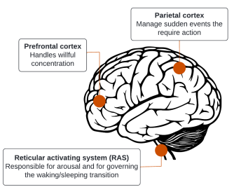

Figure ‎2‑1:Neural correlates of attention in the brain[9].

Additionally, the **frontal lobe** illustrated in (Fig.2-2) integrates attentional regulation with emotional processes, emphasizing the dual role of emotion in modulating attention. Emotional states, governed in part by the **limbic system**, can significantly impact attentiveness. Positive or mild emotional arousal can enhance focus, while extreme emotional reactions whether negative or positive may disrupt attention by overwhelming cognitive resources. The frontal regions play a key role in balancing these influences, allowing individuals to prioritize critical stimuli in emotionally charged or complex environments.[10]

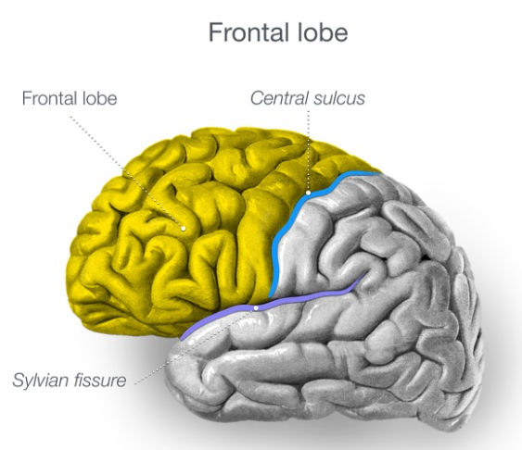

Figure ‎2‑2: The frontal lobe is by far the largest of the four lobes of the cerebrum and is responsible for many functions[10].

Understanding the interplay between these brain regions and their roles in attentional control provides a foundation for investigating variability in attentional capabilities across individuals. Moreover, it lays the groundwork for developing targeted interventions aimed at improving attention, whether in educational, clinical, or occupational contexts. These insights are particularly relevant in addressing attention-related disorders or optimizing environments where sustained focus is crucial.

## Factors Affecting Attention

Attention is influenced by numerous factors that interact with individual, environmental, and task-specific conditions. These factors can significantly impact one's ability to focus, process information, and perform tasks effectively.

Individual factors, such as age, significantly impact attention. Children typically have shorter attention spans due to the ongoing development of their cognitive systems, making them more susceptible to distractions in stimulating environments. In contrast, older adults often experience a decline in selective and alternating attention due to age-related changes in neural efficiency, particularly within the prefrontal cortex [11]. Fatigue, whether physical or mental, is another critical factor, as it impairs all forms of attention, reducing focus, increasing reaction times, and heightening susceptibility to distractions [12]. Sleep deprivation exacerbates this effect, disrupting the ability to sustain attention effectively [13]. Mental health conditions, such as anxiety and depression, further influence attention. Anxiety tends to heighten sensitivity to distractions by diverting cognitive resources to intrusive thoughts, while depression is associated with slower cognitive processing and reduced motivation, thereby diminishing attentional capacity [14]. Emotional states also play a role, with moderate arousal enhancing attention and extreme emotions overwhelming cognitive resources, leading to attentional lapses.

Environmental factors create additional challenges for maintaining attention. Noise and distractions in the surroundings can disrupt focus, especially in tasks that require deep concentration [15]. Poor lighting and visual clutter strain visual attention, making it harder to process relevant information[16]. The pervasive use of technology in daily life introduces frequent interruptions, fragmenting attention due to the constant demands of multitasking and responding to notifications [17]. These environmental conditions often interact with individual factors, compounding their effects on attentional performance.

Task-specific factors further influence attention by determining the cognitive resources required for successful task execution. Complex or poorly structured tasks demand greater cognitive effort, which can lead to mental fatigue and reduced focus over time [18]. Conversely, tasks that are overly simple may result in boredom and disengagement. The duration of a task also matters, as prolonged periods of sustained attention without breaks can lead to attentional fatigue, making it difficult to maintain focus consistently [19].

In classroom settings, unique factors come into play that significantly impact students’ attentional capacities. The instructional style adopted by educators can either enhance or hinder attention. Monotonous teaching methods often lead to disengagement, while interactive approaches, such as group discussions and multimedia presentations, are more likely to sustain student focus [20]. Physical aspects of the classroom environment, including seating arrangements, lighting, temperature, and ventilation, also affect attention. For instance, students seated farther from the instructor may experience reduced engagement, while discomfort due to inadequate ventilation or extreme temperatures can decrease focus[21]. Peer interactions in the classroom, whether collaborative or disruptive, also influence attention, as positive engagement can enhance focus while distractions can undermine it [22].

Technology in classrooms presents a double-edged sword. While digital tools like smartboards and tablets can facilitate interactive learning and improve engagement, excessive reliance on technology without proper balance can fragment attention and reduce overall learning efficiency [23].

Addressing these factors is essential for fostering an environment conducive to sustained attention, both in educational contexts and beyond.

## Electroencephalography (EEG)

Electroencephalography (EEG) is a widely employed technique for measuring the brain's electrical activity, offering a non-invasive and practical means of studying neural dynamics. By capturing the electromagnetic waves generated by neurons during synaptic excitations, EEG provides a direct representation of the brain's electrical currents. These currents primarily arise from the dendrites of **pyramidal neurons** within the cerebral cortex, where excitatory and inhibitory neural activities converge to produce the detectable signals.

The process of EEG involves the use of small, flat metal discs called **electrodes**, which are strategically positioned on specific scalp locations. These electrodes act as sensors, detecting the brain's electrical impulses and transmitting them to a computer system for visualization and analysis as illustrated in (Fig.2-3). The captured signals are displayed as brain wave patterns, revealing the rhythmic oscillations associated with different mental states, cognitive tasks, or physiological conditions. This data serves as a critical diagnostic tool for identifying irregularities in neural communication and detecting neurological disorders, such as epilepsy and sleep-related issues[24].

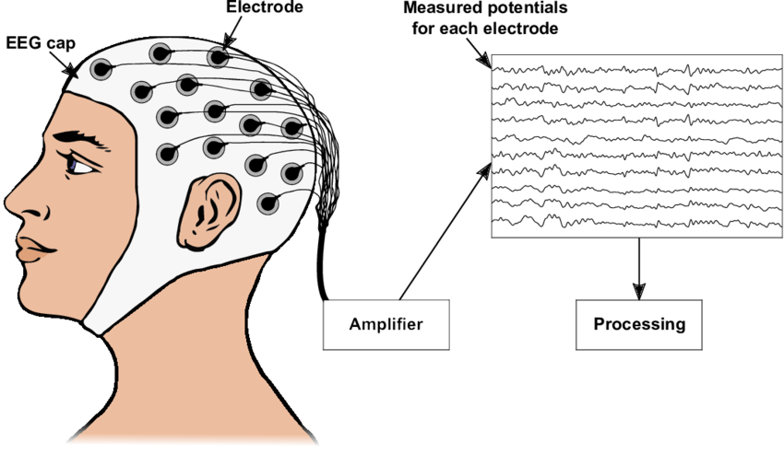

Figure ‎2‑3: Sketch of how to record an Electroencephalogram[22].

EEG’s utility extends beyond clinical diagnostics to a wide range of applications in neuroscience, psychology, and cognitive science. Researchers use EEG to monitor brain activity during mental tasks, resting states, and responses to external stimuli, such as audio-visual inputs. The recorded signals are commonly presented in the time domain, with their characteristics such as frequency, amplitude, and waveform providing insights into the underlying neural processes. Depending on the experimental or clinical requirements, EEG can be recorded from electrodes placed over the scalp, beneath the skull, or directly on the cerebral cortex. These diverse recording formats enhance its adaptability for various research and diagnostic purposes[25].

EEG’s ability to provide real-time data on brain activity has made it a cornerstone technology in understanding the relationship between neural activity and mental states. It has been extensively used to explore attention, cognition, emotion, and memory processes, among others. The technique also plays a significant role in brain-computer interface (BCI) systems, where it enables direct communication between the brain and external devices by interpreting neural signals. This adaptability underscores EEG's significance as a versatile and indispensable tool for advancing our understanding of brain function and its applications across diverse fields.

### EEG Frequency Bands and Their Association with Attention.

EEG signals are broadly categorized into five frequency bands, each representing specific neural activities and cognitive states as illustrated in (Fig.2-4). These bands are alpha (α) 8-12 Hz, beta (β) 12-30 Hz, theta (θ) 4-8 Hz, delta (δ) 1-4 Hz, and gamma (γ). Each frequency band corresponds to different states of cognitive activity and they provide valuable insights into brain function, including attention, emotional states, and cognitive processes [26],[27].

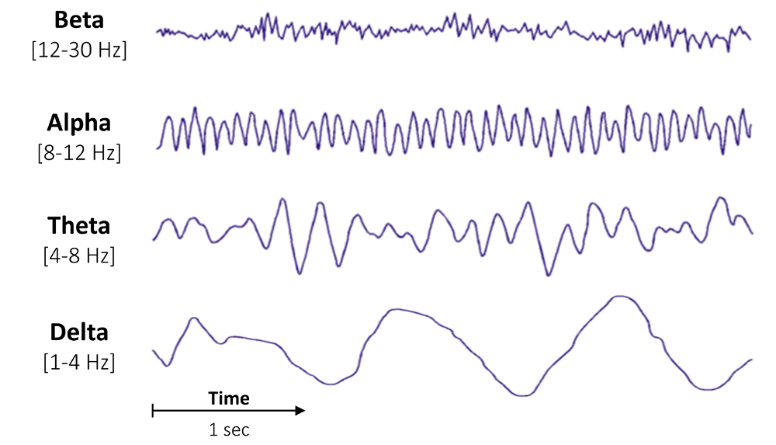

Figure ‎2‑4: The image illustrates the four primary types of brain wave frequencies commonly measured using EEG[27].

* **Alpha (α) Waves**: These waves range from 8 to 13 Hz with amplitudes of 30–50 µV. They are typically observed in the parietal and occipital brain regions during states of consciousness, rest, or relaxation. Alpha waves diminish, known as "alpha blocking," when an individual engages in mental tasks or sensory stimulation [28].
* **Beta (β) Waves**: Ranging from 14 to 30 Hz with amplitudes of 5–20 µV, beta waves are prevalent in the frontal region during states of alertness, active thinking, and sensory processing. They are closely associated with mental activation and focus, as indicated by studies [29].
* **Theta (θ) Waves**: These waves have frequencies between 4 and 7 Hz and amplitudes below 30 µV. They occur in the parietal and temporal regions during deep relaxation, emotional stress, or interruptions of consciousness, reflecting lower engagement levels.
* **Delta (δ) Waves**: With frequencies of 0.5 to 3 Hz and amplitudes ranging from 100 to 200 µV, delta waves dominate during deep sleep or unconscious states, showing minimal activity in awake adults.
* **Gamma (γ) Waves**: The fastest of the EEG bands, gamma waves range from 31 to 50 Hz with amplitudes of 5–10 µV. Studies have linked gamma activity to selective attention, cognition, and perceptual tasks. Duann et al. observed an increase in gamma waves during relaxation, emphasizing their role in attention mechanisms.

Research by Ray and Cole [30] confirmed that EEG activities, particularly in the alpha and beta bands, are closely tied to attention. For instance, Klimesch et al [28]. found that alpha wave amplitudes reduce significantly during mentally demanding tasks, indicating heightened focus. Beta activity, on the other hand, is directly linked to mental state activation, reflecting active cognitive processing during attention-related activities. Gola et al.[31] found that beta-band power of EEG signal recorded over occipital regions is related to visual attention. [Wöstmann et al.](https://pmc.ncbi.nlm.nih.gov/articles/PMC8143791/#bib46)[32] Found that alpha power band could be tracked to determine the locus of auditory attention. Despite these insights, more research is needed to fully understand the neural patterns underlying attention in EEG signals.

## Approaches For Evaluating Attention In Cognitive Research and Practical Applications.

1. **Electroencephalography (EEG):** EEG is a non-invasive method that measures electrical activity in the brain. By analyzing brain waves, EEG helps in assessing different states of attention, including focused attention, distraction, and cognitive workload. Specific frequency bands such as alpha, beta, and theta waves are often used to distinguish levels of attention and alertness[29].
2. **Behavioral and Cognitive Tests:** These tests involve tasks such as the Stroop test, continuous performance task (CPT), or the Digit Span task, which measure sustained, selective, and divided attention. Performance on these tasks can provide insight into an individual’s capacity for maintaining focus, filtering distractions, and multitasking [33].
3. **Functional Neuroimaging:** Methods like functional Magnetic Resonance Imaging (fMRI) and Positron Emission Tomography (PET) are used to observe brain activity in real time during attention-demanding tasks. These imaging techniques identify brain areas involved in attention, such as the prefrontal cortex, and can detect dysfunctions associated with attention disorders [34].

## Conclusion

Attention is a vital cognitive function that plays a crucial role in human interaction with the environment. Its complexity, involving both psychological and neural mechanisms, governs how individuals prioritize and process stimuli, directly influencing cognitive functions such as memory, learning, and problem-solving. The interplay between various brain regions, especially within the frontal and parietal lobes, underlines the multifaceted nature of attentional processes. Moreover, attention is shaped by individual, environmental, and task-specific factors, which can either facilitate or hinder the ability to maintain focus. Advances in neuroscience and tools like EEG offer promising avenues for objectively assessing and enhancing attention, particularly in contexts such as education, where optimal attention is critical for effective learning. The ongoing exploration of attention’s neural basis and its implications for cognitive behavior will continue to inform strategies aimed at improving attention in both clinical and educational settings.

# LITERATURE REVIEW

## Historical Background

In this Chapter, we focus on the exploration of machine learning applications in EEG-based attention detection, specifically targeting studies that analyze neural signals to classify attention states. The rapid advancements in EEG acquisition technologies, combined with the growing capabilities of machine learning, have enabled new methodologies to interpret the complexity of brain signals with high precision. This review is based on carefully selected papers that meet specific criteria, prioritizing studies employing machine learning algorithms like Support Vector Machines (SVMs), Random Forests (RFs), and Artificial Neural Networks (ANNs). These approaches have proven instrumental in identifying patterns within EEG signals, driving advancements in understanding attention dynamics.

## Machine learning

Machine learning (ML), a subset of artificial intelligence, involves using mathematical models and algorithms to improve the performance of specific tasks through training data without explicit programming. It encompasses supervised learning that involves training models on labelled data, where input data is paired with corresponding output labels and unsupervised learning were hidden patterns or structures in the data are discovered through learning from unlabeled data. The goal is to find underlying patterns or structures in the data, offering flexibility across diverse applications[35] as illustrated in (Fig 3-1).

In bio signal processing, including electroencephalography (EEG), ML provides a robust framework to analyze complex and high-dimensional data, enabling insights into intricate patterns and features that are otherwise difficult to discern[36]. Particularly in EEG-based attention detection, ML can manage noisy and dynamic data while adapting to evolving conditions that influence signal acquisition[37]. By applying techniques like signal enhancement, feature extraction, and classification, ML enhances the accuracy and efficiency of attention detection systems. This adaptability and capability make ML an essential tool for advancing bio-signal processing, optimizing performance in areas such as real-time monitoring, cognitive load assessment, and neurofeedback applications[38]. Through the use of ML, researchers can uncover hidden patterns, refine models for precision, and push the boundaries of attention detection in educational and interactive paradigms.

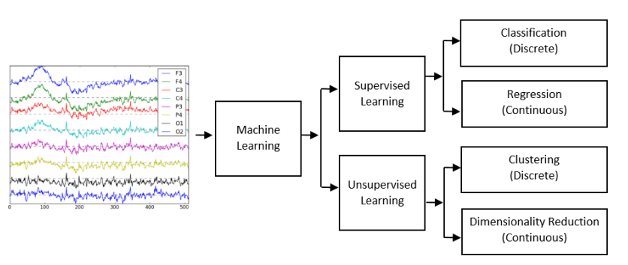

Figure ‎3‑1:. Supervised learning is categorized to classification. And unsupervised learning is categorized to clustering and dimensionality[38].

## EEG Functional Connectivity

Traditional EEG analysis primarily focused on features extracted from individual electrodes in the time or frequency domain. While useful, this approach overlooks the fact that cognitive functions such as attention arise from **interactions between multiple brain regions**. This realization led to the emergence of **functional connectivity** analysis in EEG research.

Functional connectivity refers to the quantification of statistical relationships between EEG signals recorded from different scalp locations. Depending on the analysis goal, different types of connectivity are used. **Time-domain** connectivity assesses direct correlations or covariations in raw signals, while **frequency-domain** approaches evaluate synchrony between brain regions at specific frequency bands. More recently, **information-theoretic** and **phase-based** measures have been introduced to capture non-linear and directional relationships in EEG data. These connectivity relationships are typically represented in matrices, where the strength of interaction between different brain regions or electrodes is visually conveyed see Figure 3-2 for an example.

These methods have significantly advanced the understanding of brain network organization, enabling researchers to move beyond isolated channel analysis toward a network-based view of cognition and mental states such as attention.

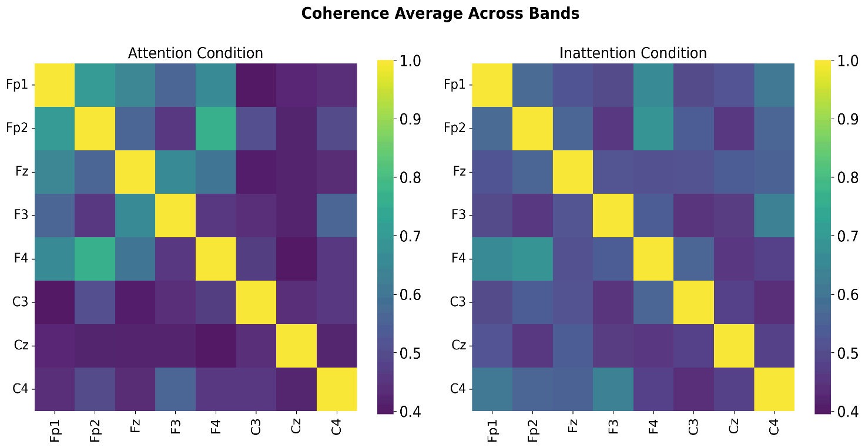

Figure ‎3‑2: Example coherence connectivity matrices. Color intensity indicates the strength of coherence between EEG electrode pairs.

## Graph Theory in EEG Signal Analysis

As functional connectivity methods became more sophisticated, researchers needed tools to interpret the resulting complex inter-regional interaction patterns. This led to the application of **graph theory** in EEG analysis. In this context, the brain is modelled as a network, with EEG channels or brain regions represented as **nodes**, and their functional relationships (derived from connectivity analysis) as **edges**. These network representations allow for a visual understanding of brain connectivity, as exemplified in Figure 3-3, where nodes represent EEG electrodes and edges depict their functional relationships.

Graph theory enables the extraction of **network-level features** that describe both the global and local organization of brain activity. These include **node-level metrics** that reflect the importance or connectivity of specific regions, **clustering features** that indicate localized group interactions, and **global features** that describe the overall integration and efficiency of the network.

Graph-based analysis provides a powerful and interpretable framework to study how attention manifests at the network level, offering insights that are not accessible through traditional EEG feature extraction. It also bridges the gap between neuroscience theory and machine learning-based classification by converting complex brain dynamics into structured, quantifiable patterns.

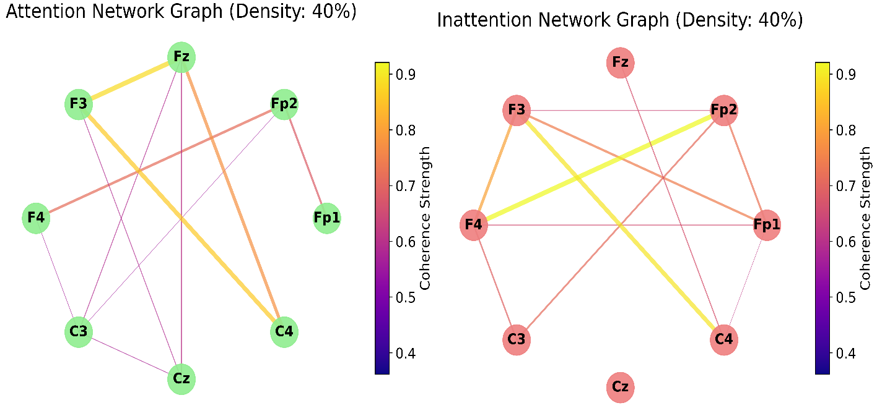

Figure ‎3‑3: Brain network graphs representing functional connectivity patterns during Attention (left) and Inattention (right) cognitive states, both depicted at a density of 40%.

## State of the Art

### Time-Domain Features extraction approaches

Li et al.(2011) [39], Critically examines the limitations of existing attention recognition (AR) methods and introduces EEG-based approaches to enhance AR accuracy. Previous research predominantly focused on visual cues such as eye-gaze and head pose, which are limited by environmental dependencies and subjective variability. The authors commendably pivot toward EEG signals, emphasizing their potential for real-time, non-invasive AR applications, offering richer data on cognitive states. Key contributions include the application of FastICA for noise reduction and KNN and Naive Bayes classifiers for feature extraction. While the results, with classification accuracies of 51.9% for five attention levels and 63.9% for three, are promising, the authors acknowledge challenges such as classifier sensitivity to training data selection as illustrated in (Fig 3-4).

Although classification rates are moderate, the study suggests EEG as a valuable AR tool that could complement visual methods. This approach provides a foundation for applying EEG in varied AR applications, including potentially auditory attention detection.

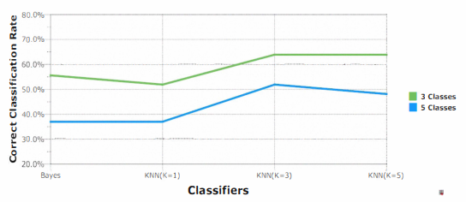

Figure ‎3‑4: Comparison of the highest correct classification rates on 3 and 5 classes with different K-values[39].

### Frequency-Domain Features extraction approaches

Liu et al. (2013)[40], Advances the field of attention recognition (AR) by exploring EEG-based methodologies tailored to classroom learning. While traditional AR approaches rely on subjective observation. The data was collected from 24 participants (12 males and 12 females) aged 22–27, under controlled experimental conditions.

This research leverages mobile EEG sensors and Support Vector Machines (SVM) to achieve a classification accuracy of 76.82%, offering an objective alternative. Notable contributions include the extraction of key EEG features alpha, beta, theta, and delta wave activities and their integration into an SVM model showing significant relevance as shown in Table 3-1 the results indicated that attentive states were more accurately classified than inattentive ones, suggesting that inattentive EEG data may contain more variability. The study proposes that EEG signals could offer a practical solution for assessing attention in real-time, supporting educational environments, especially in online or multimedia learning contexts. The study’s strengths lie in its focus on portable EEG devices and real-world classroom applicability. However, limitations include the constrained participant pool of 24 subjects and reliance on subjective labelling of attentive and inattentive states, which could introduce bias. Compared to earlier work, the study effectively bridges the gap between experimental setups and practical implementation, particularly for monitoring student attention.

Table ‎3‑1: The inference of classification accuracy using various features [40].

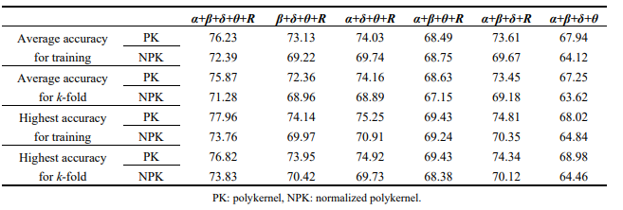

Alirezaei et al. (2018) [41], Developed an EEG-based system to detect human attention by classifying cognitive states through systematic signal processing and machine learning. This study acknowledges the growing interest in using EEG for applications like attention monitoring, particularly in education and clinical environments, where objective measurements of attention can enhance learning or therapeutic outcomes. EEG signals were recorded from participants using the 10-20 system, which is a widely accepted method for electrode placement to capture neural activity across brain regions involved in attention. To ensure the quality of the EEG data, the researchers applied various preprocessing techniques, including filtering, to eliminate noise and physiological artifacts that might otherwise interfere with accurate feature extraction. The feature extraction phase focused on identifying relevant EEG characteristics across several frequency bands, including delta, theta, alpha, and beta.

These selected features were then used to train machine learning classifiers, specifically focusing on c-SVM. The results indicated that c-SVM achieving average accuracies of 92.8% in differentiating between attentive and inattentive states. This study’s contributions lie in its robust approach to feature extraction and selection, which improves the reliability of EEG-based attention classification.

Nuamah and Seong. (2018)[42], explores the application of the Task Engagement Index (TEI) for classifying cognitive tasks using SVMs. Earlier studies, such as those by Pope et al. and Freeman et al., established TEI (beta/(alpha + theta)) as an effective indicator of cognitive workload. However, their findings often lacked robust classification methods and generalized datasets, leading to limited practical applications. This study builds on that foundation by employing data from six participants who performed five cognitive tasks. TEI was extracted using time-frequency representation and analysed statistically to confirm significant task differentiation and create a scalp topological distribution of grand average across all six participants for four cognitive tasks relative to baseline spectral power for frequency bands theta, alpha, and beta as shown in (Fig 3-5).

The study used SVMs with three kernel types (linear, RBF, polynomial), achieving a classification accuracy of 93.33% with the RBF kernel. Compared to linear models in prior works, the nonlinear kernel improved accuracy and adaptability. This study highlights the gap in developing adaptive systems for dynamic cognitive state monitoring and provides a foundation for further advancements in EEG-based applications.

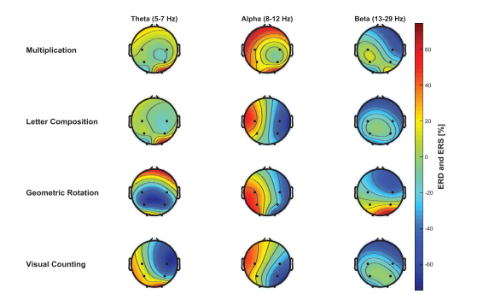

Figure ‎3‑5: Scalp topological distributions of grand [42].

Al-Nafjan and Aldayel. (2022)[43], address the challenges of monitoring student attention in online learning environments by proposing a brain-computer interface (BCI) system that utilizes EEG data. Previous research, such as Aci et al.[44], focused on passive EEG-based systems for attention detection, achieving an accuracy of 96.7% using Support Vector Machine (SVM) classifiers but limited by a narrow range of mental states assessed. Al-Nafjan and Aldayel significantly advance this area by employing a dataset comprising EEG recordings from five participants engaged in a low-intensity control task, focusing specifically on the "focused" and "unfocused" attention states. They utilized power spectral density (PSD) and compute power-ratio features extracted from the EEG signals, which allowed for a more detailed analysis of attention levels. The study implemented three classification models Random Forest (RF), (KNN), (SVM) which achieved using holdout validation 96%,74%,78% respectively as shown in Table 3-2.

The innovative use of real-time monitoring capabilities in their BCI system represents a significant step forward in applying EEG technology in educational settings.

Table ‎3‑2: Results for attention recognition using holdout validation and the different classifiers SVM, RF, and KNN [43].

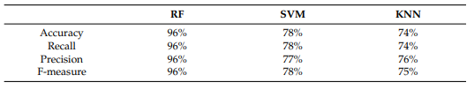

### Nonlinear Features extraction approaches

Ke et al. (2014) [45], Emphasize the application of nonlinear dynamic features in recognizing visual attention states using EEG signals. Unlike traditional methods that rely on linear parameters such as power spectrum. This research investigates Approximate Entropy (ApEn), Sample Entropy (SampEn), and Multiscale Entropy (MSE) for classifying attention levels. The dataset includes EEG recordings from 14 right-handed participants aged 20–30, collected under controlled laboratory conditions during tasks involving three attention levels: attention, no attention, and rest. The study compares the performance of these nonlinear features using Support Vector Machines (SVMs) with radial basis function kernels as shown in (Fig 3-6).

SampEn emerged as the most effective feature, achieving classification accuracies of 76.19% in Experiment 1 and 85.24% in Experiment 2, surpassing the theta-to-beta power ratio, a commonly used linear metric. MSE's performance declined with increasing scale factors, indicating limitations in capturing attention state dynamics at higher scales. As shown in the classification results, combining features from channels F3, F4, F7, F8, and Fz yielded optimal performance. This work builds upon foundational research on entropy by Pincus and Costa[46] and addresses the gap in using nonlinear dynamics for robust attention recognition.

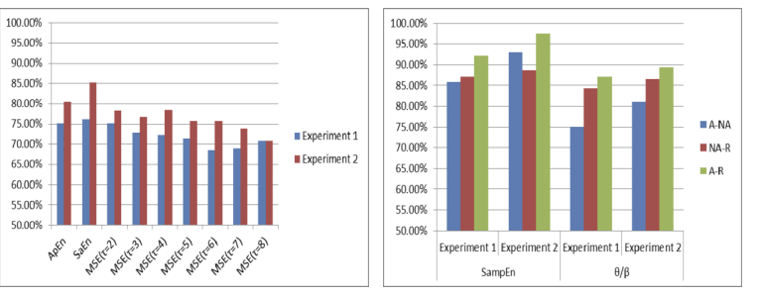

Figure ‎3‑6: The 3-class classification results for dynamical parameters (left) and the 2-class classification (right) [45].

Wan et al. (2021) [47], Explores multi-level attention recognition using EEG signals, filling critical gaps left by previous research. Existing studies primarily focused on binary attention tasks, such as distinguishing rest versus attention (Chen et al., [48]; Hu et al.,[49]). These works relied on traditional EEG metrics, including power spectral density and linear analysis, achieving accuracies between 75% and 91% for binary classifications. However, they struggled to address the nonstationary and nonlinear properties of EEG signals, limiting their effectiveness for multi-level attention tasks. This study significantly advances the field by incorporating dynamical complexity measures such as Approximate Entropy (ApEn), Sample Entropy (SampEn), and Fuzzy Entropy (FuzzyEn) combined with Extreme Gradient Boosting (XGBoost) for classification. Data was collected from 42 participants, providing EEG signals for four attention levels (rest, low, medium, and high). Using 5-fold cross-validation, the proposed Complexity-XGBoost model achieved accuracies of 95.36% for two-level, 80.42% for three-level, and 81.39% for four-level classifications, outperforming conventional methods like SVM and Random Forest. This paper addresses the gap in transitioning from binary to multi-level attention recognition, offering a robust methodology that could be pivotal for applications in education, cognitive assessment, and neurofeedback therapy.

### Time-Frequency and Decomposition-Based Features extraction approaches

Djamal et al.(2016)[50], critically evaluates the development of EEG-based systems for attention recognition. Previous research in the field, such as Liu et al.[40] and Benedek et al. [51], relied on traditional linear methods like Fast Fourier Transform (FFT) for feature extraction, achieving moderate accuracies of 70–80%. These approaches often ignored the nonlinear and nonstationary nature of EEG signals, limiting their robustness for real-world applications. Djamal et al. address these limitations by proposing a method combining wavelet transform for feature extraction and a multi-class Support Vector Machine (SVM) for classification.

EEG signals were recorded from 8 participants using a 6-channel system. The signal recorded of four subjects as data training and four subjects as data testing. It divided into two parts; eight minutes used blue light stimulation as attention state and continued the next eight minutes without light as inattention state. Using wavelet filter could improve system accuracy from 44-58% to 69-83%. The influence of channel pairs showed that channels C3 and C4 are relatively more accurate than the other two pairs of channels as shown in Table 3-3.

Table ‎3‑3: The effect of the wavelet filter on the recognition accuracy [50].

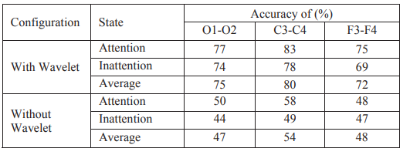

Chen et al.(2017)[48],Synthesizes advancements in EEG-based attention recognition within e-learning environments. Existing literature, such as Liu et al.[40] and Chen & Huang[52], highlights the importance of sustained attention for effective learning, yet these studies often rely on small datasets and traditional methods like subjective attention scales or linear EEG analysis, achieving limited accuracy 76.82%.Chen et al. address these gaps by capturing single-channel EEG signals from 10 students during a continuous performance test (CPT).The authors utilized the discrete wavelet transform (DWT) to extract features from five EEG frequency bands.

Additionally, five statistical parameters approximate entropy, total variation, energy, skewness, and standard deviation were calculated for each band using DWT as illustrated in (Fig 3-7). With feature selection optimized using a genetic algorithm (GA) as shown in the flowchart in (Fig 3-8). Their Attention Aware System (AAS) achieved a prediction accuracy of 89.52%, significantly outperforming previous methods. This study bridges a gap by integrating advanced feature selection with machine learning for attention monitoring, offering a foundation for enhancing e-learning experiences.

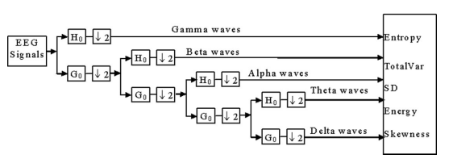

Figure ‎3‑7: The architecture of discrete wavelet transforms (DWT) for extracting (EEG) features[48].

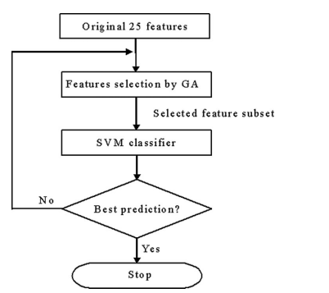

Figure ‎3‑8: The flowchart of the employed GA-LIBSVM algorithm [48].

Parui et al.(2021)[53], investigates the use of EEG signals to classify attention states, particularly in the context of online learning, where student engagement is critical. Previous research, including Studie by Chen et al.[48], has highlighted the potential of EEG for cognitive state assessment and artifact removal; however, these studies often fell short in integrating effective classification techniques and real-time applications, limiting their practical utility. This study advances the field by employing a hybrid approach that combines empirical mode decomposition (EMD) and canonical variate analysis (CVA) for artifact suppression, followed by a stacked generalization classifier to enhance the accuracy of attention state classification. The authors conducted experiments with 20 participants in a driving simulator, achieving classification accuracies of 92.7%, 95.234%, and 98.36% for high, moderate, and low attention levels respectively.

Peng et al. (2020) [54], critically addresses the challenge of attentiveness recognition, building on prior studies that leveraged linear techniques like Fast Fourier Transform (FFT) and approximate entropy. These traditional approaches, as highlighted in the literature, achieved accuracies around 73.94%–76.82%, but struggled with nonlinear and nonstationary nature of EEG signals. The authors contribute a novel method employing Hilbert–Huang Transform (HHT) and Empirical Mode Decomposition (EMD) to extract time-frequency features for more accurate classification the study’s methodology is illustrated in (Fig 3-9). Key works in the field include Liu et al.'s use of FFT for power spectral density[29] and Aziz et al.'s application of HHT for EEG-based attention [41]. While these studies laid the groundwork, they often relied on multi-channel systems and lacked generalization to single-channel devices. Peng et al. advance the field by demonstrating the feasibility of single-channel EEG systems with high classification accuracy (84.8% average, 93.5% maximum). Figure 3-10 shows the marginal spectra of IMFs, which were crucial for identifying state-specific EEG characteristics. Additionally, figure 3-11 visualizes the HHT-derived time–frequency–energy spectrum, highlighting the differences in brain activity between attentive and relaxed states. However, their dataset of 20 participants limits the generalizability of the findings, and reliance on controlled experimental tasks reduces applicability in real-world scenarios. This study bridges a critical gap by showcasing the potential of single-channel EEG for attentiveness detection while integrating nonlinear analysis methods.

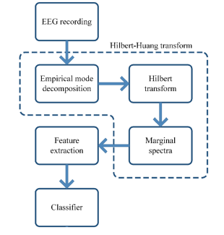

Figre ‎3‑9: The flowchart of the proposed method. [54].

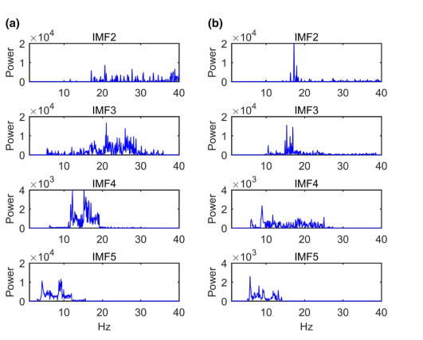

Figure ‎3‑10: Marginal spectra of IMF2–5 when the representative participant was a paying attention and b taking a rest [54].

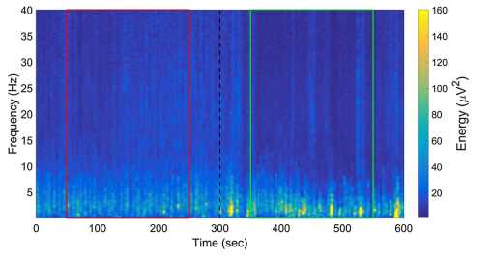

Figure ‎3‑11: The HHT spectrum of the energy distribution. [54].

### Hybrid features extraction approaches

Xu et al. (2023) [55], Builds on previous research in EEG-based attention recognition by addressing the need for classifying multi-level attention states, a less explored area in the field. Prior studies predominantly focused on binary attention classification using external indicators such as eye movements or single EEG features While these methods demonstrated moderate success, they lacked robustness and scalability for real-world applications. Xu et al. advanced the field by designing an experimental framework to classify four attention levels (high, medium, low, and non-directed) in 14 participants. Using EEG signals recorded from 10 channels, the study extracted a comprehensive set of 10 features, including time-domain metrics, sample entropy, and frequency band energy ratios. A Sequential Forward Selection (SFS) algorithm optimized the feature set, leading to an improved classification accuracy of 94.1% using a Support Vector Machine (SVM) classifier, surpassing the initial accuracy of 88.7%. This study highlights the importance of feature selection in improving classification accuracy while reducing computational complexity.

Chen et al. (2023) [56], Addresses the limitations of traditional attention recognition paradigms by integrating multiple feature types to enhance accuracy in intra- and inter-subject classification. Existing research, such as Hamadicharef et al[57]. focused on temporal and spatial filters for attention classification, achieving 89.4% accuracy within a small participant pool. Wan et al[47]. advanced this work using dynamical complexity measures like entropy but remained constrained by dataset size and feature generalizability. Chen et al. significantly expands upon prior studies by proposing a novel paradigm as illustrated in (Fig 3-12).

Involving mental arithmetic tasks to induce attention states and employing a 32-channel EEG setup. The study analyzes EEG signals from 85 participants, the largest dataset in this field to date. Features from the time domain (mean, skewness), frequency domain (power spectral density, band ratios), and non-linear dynamics (approximate entropy, wavelet entropy) were fused, creating a 123-dimensional feature vector. Using Random Forest (RF), Support Vector Machine (SVM) classifiers and Decision Tree DT, the proposed framework achieved intra-subject accuracy of 85.05% as shown in (Fig 3-13). and inter-subject accuracy of 81.60% as shown in (Fig 3-14), outperforming baseline models such as PSD-SVM and Dynamical Complexity-XGBoost. The research identifies a critical gap: scalable attention recognition systems applicable in real-world scenarios.

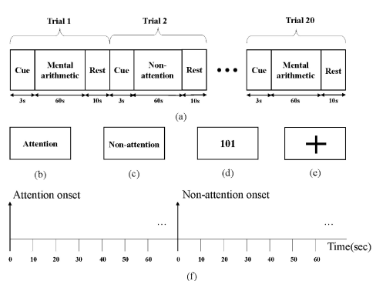

Figure ‎3‑12: Attention paradigm protocol

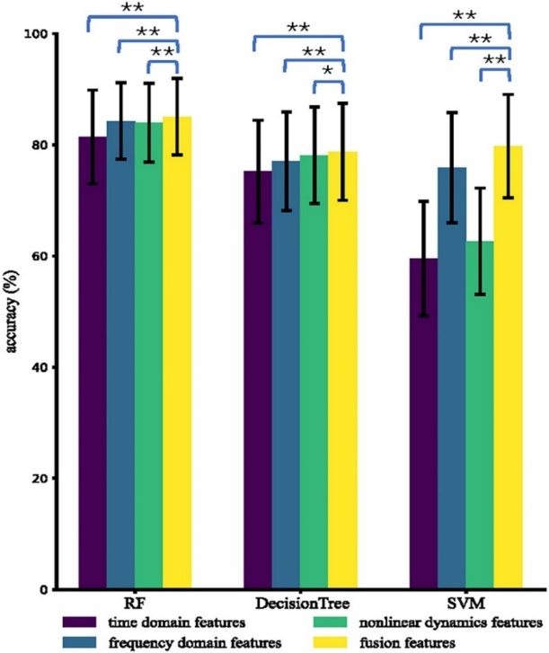

Figure ‎3‑13: Average intra-subject accuracies using different types of features and different classifiers[56].

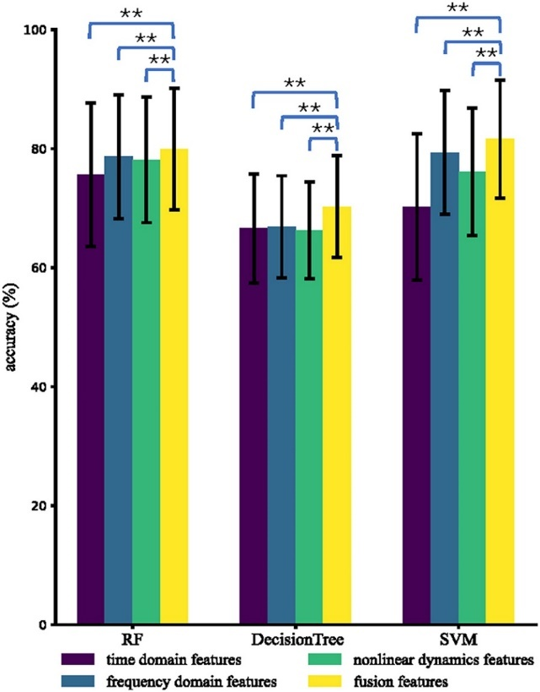

Figure ‎3‑14: Average inter-subject accuracies using different types of features and different classifiers[56].

## Comparison and Conclusions

This section highlights recent research on the application of Traditional Machine learning (ML) Like Support vector machine (SVM), Decision Tree (DT), XG-boost, Random Forest (RF) And Artificial Neural networks (ANN’s) Like MLP For classification and detection of the attention using EEG signals.

Table ‎3‑4: Comparative Table of Several attention detection studies using machine learning and Artificial Neural networks.

|  |  |  |  |
| --- | --- | --- | --- |
| **Paper** | **Dataset** | **Method** | **Result** |
| Li et al.[39]  2011 | EEG data recorded using 4 channel F3, F4 and Cz from 10 Subjects  Exposed to multimedia  contents | **Features:** 13 From alpha  And theta waves  **Classification Model:**  KNN | KNN achieving 63.9% accuracy for 3-class at K=5. |
| Liu et al.[40]  2013 | EEG data were collected using 1 channel Fp1 from 24 participants while they performed tasks under both attentive and inattentive conditions. | **Features:** (alpha, beta, delta, and theta) wavebands  **Classification Model:**  SVM | The highest classification accuracy was 76.82. |
| Ke et al.[45]  2014 | EEG data were recorded from 19 electrodes and involved 14 participants who performed tasks across three attention levels: attention, no attention, and rest. | **Features:** (ApEn), (SampEn), and (MSE).  **Classification Model:**  SVM with a Gaussian Radial Basis Function (RBF) kernel for classification. | SVM achieving classification accuracies of 76.19% and 85.24% across two experimental conditions |
| Djamal et al.[50]  2016 | The EEG signal recorded from 8 subject, using 6 they used light stimulation | **Feature extraction:** Wavelet transforms.  **Classification Model:**  SVM | SVM improve accuracy to 83%. |

|  |  |  |  |
| --- | --- | --- | --- |
| Chen et al.[48]  2017 | EEG signals were collected using 1 electrode from 10 performing CPT, in this study. | **Feature extraction:** (DWT) **Features:** (ApEn), total variation, energy, skewness, and standard deviation  **Classification Model:**  SVM | SVM achieved a prediction accuracy of 89.52%. |
| Alirezaei et al.[41]  2018 | EEG signal was recorded using 8 channels F3, F3, F5, F6, F4, F4 F7 from 12 subject seated in front of a monitor that stream a series of images of some numbers | **Features:** 6 features from the subbands of the signal, the maximum power, Entropy, Energy of bands, peak to peak values, mean value and ratio of alpha and beta band energy. **Classification Model:**  Using SFS the best features were fed into an SVM | The SVM has average accuracy of 92.8% |
| Nuamah and Seong.[42]  2018 | EEG data collected data from 6 channels C3, C4, P3, P4, O1, and O2 from six participants performing 5 task baseline, multiplication, letter composition, geometric figure rotation, and visual counting. | **Features:** 6 power spectrum features extracted using STFT **Classification Model:** SVM. | SVM model achieving a classification accuracy of 93.33% with  the RBF kernel. |
| Peng et al.[54]  2020 | EEG data recorded using 1 channel electrode (Fp1) of 20 subject. Two tasks were conducted by the participants: (1) pay their attention to solving designated spot-the-difference puzzles shown on a screen for 5 min; (2) then relax with their eyes opened and fixated at a blank screen for 5 min. | The authors contribute a novel method employing Hilbert–Huang Transform (HHT) and Empirical Mode Decomposition (EMD) to extract time-frequency features with **Classification Model:** SVM | The average classification accuracy was 84.80%. |
| Wan et al.[47]  2021 | The EEG data were recorded by 32 electrodes from 42 subject doing The attention continuous performance test (CPT) | **Features:** (ApEn), SpEn, and Fuzzy Entropy  **Classification Model:** (XGBoost) | Model achieved accuracies of 95.36% for two-level, 80.42% for three-level, and 81.39% |
| Parui et al.[53]  2021 | EEG signal collected using 21 channels from 20 subjects. The subjects were asked to sit comfortably in the seat and grab the steering wheel in a virtual driving simulator. | **Features:** extract entropy features using EMD  **Classification Model:** stacked generalization model is employed consist of Multiple machine learning models logistic regression as a metamodel. SVM, RF, and XGBoost | SVM achieving classification accuracies of 92.7%, 95.234%, and 98.36% for high, moderate, and low attention levels, respectively. |
| Nafjan and Aldayel.[43]  2022 | A publicly available dataset in Kaggle was analyzed in this study. comprising EEG recordings from five participants engaged in a low-intensity control task for 3 mental states. | **Features:** They utilized power spectral density (PSD) and compute power-ratio features **Classification Model:** RF, KNN, SVM. | RF achieving the highest accuracy 96%. |
| Chen et al.[56]  2023 | EEG signals recorded using a 32-channel from 85 subject and the use mental arithmetic and resting tasks to induce attention. | **Features:** Hybrid Features extraction  **Classification Model:** RF, DT, SVM. | RF achieving the highest accuracy 98%. |
| Xu et al.[55]  2023 | EEG signal recorded from 10 channels Fp1, Fp2, F3, F4, C_3, C4, P3, P4, O1 and O2 from 14 subjects. | **Features:** 10 features, including time-domain and Frequency domain  And the use (SFS) algorithm optimized the feature set.  **Classification Model:** SVM. | classification accuracy of 94.1%. |

Table ‎3‑5: A summary of advantages of methodologies, and limitations of each study, highlighting the diversity of approaches and gaps in scalability, participant diversity, and real-world applicability.

|  |  |  |
| --- | --- | --- |
| **Paper** | **Advantages** | **Limitations** |
| Li et al.[39] | Effective noise reduction using FastICA. | Classifier performance sensitive to training data; lacks real-world validation. |
| Liu et al.[40] | Portable EEG sensors; SVM optimized for high accuracy (76.82%). | Small participant pool; subjective task labelling affects generalizability. |
| Ke et al.[45] | Novel use of SampEn and MSE for classification; significant improvement over linear methods. | Small sample size; no real-world validation. |
| Djamal et al.[50] | Combines wavelet transform for feature extraction with SVM classification, achieving high accuracy of 83%. | Experimental settings in controlled environments restrict generalizability to real-world scenarios. |
| M.P and Mozaffari.[58] | Robust feature extraction with DWT. The system recognizes four distinct levels of attention | The study involved a limited number of subjects ONLY 4. The classification accuracy may be affected by noise and artifacts in the EEG data |
| Alirezaei et al.[41] | High accuracy 92.8%. New protocol that didn’t need a strong memory. Using fisher criterion in features engineering. | The obtained result was subject-dependent. The limited number of subjects make difficult to draw a conclusion about the common characteristic of each subject. |
| Nuamah and Seong.[70] | They used task engagement indices as inputs to SVM to allow identification and classification of cognitive engagement which led to a high classification accuracy 93.33%. | Limited participant size (6); lacks scalability to real-time applications. |
| Peng et al.[54] | The integration of **Hilbert-Huang Transform** for analysing EEG signals allows for the extraction of nonlinear and nonstationary features. | Single-channel dependency limits scalability. |
| Wan et al.[47] | The Use of Dynamical Complexity Features. he proposed Complexity-XGBoost model achieved an accuracy of 81.39% for four attention levels and 95.36% for two attention levels. | The limitation of this study is that the time course of AXCPT tasks was not sufficiently long, resulting in the reaction time not being able to progress overtime to produce more obvious changes. |
| Parui et al.[53] | The proposed stacked generalization classifier outperformed traditional classifiers with a mean accuracy of 92.7%, 95.234%, 98.36% for high, moderate, and low levels of attention classes respectively. | The proposed methods require sophisticated algorithms and computational resources, which may not be readily available in all settings. |
| Nafjan and Aldayel.[43] | Achieved high accuracy (96%) with a Random Forest classifier; effective use of PSD features and FFT. | Small dataset (5 participants); limited to controlled online learning environments. |
| Chen et al.[56] | High intra-subject accuracy (85.05%) and inter-subject accuracy (81.60%); innovative feature fusion method combining time, frequency, and nonlinear dynamics. | Large number of EEG channels (30) required; lacks real-time validation; experimental settings limit scalability. |
| Xu et al.[55] | Sequential forward selection of optimal features balancing computational complexity and performance. | experimental conditions restrict scalability to real-world settings. |

In conclusion, this review highlights the steady progress in EEG-based attention and mental state recognition using traditional machine learning models and neural networks. A wide variety of features ranging from time-domain statistics to frequency-based and nonlinear metrics have been used in combination with classifiers like SVM, Random Forest, and MLPs. Techniques such as wavelet transforms, entropy analysis, and statistical feature selection have demonstrated effectiveness in detecting attentional and cognitive states.

Despite these advances, key limitations remain. Most studies extract features independently from EEG electrodes, ignoring the complex inter-regional interactions underlying brain function. While a few recent works have explored deep learning models like GCNNs, their lack of interpretability remains a barrier to practical adoption. Moreover, many approaches rely on large numbers of electrodes, controlled lab environments, and narrowly defined task paradigms, limiting scalability and ecological validity.

To address these gaps, future research should prioritize network-based approaches that reflect the brain’s functional architecture. Graph-theoretical analysis of functional connectivity offers a promising direction for extracting meaningful, interpretable features. Additionally, simplifying EEG setups, integrating multimodal and realistic stimuli, and validating on diverse populations will be crucial steps toward developing robust and practical attention detection systems across domains such as education, mental health, and human-computer interaction.

# METHODOLOGY

This chapter presents the methodology adopted for the study of EEG-based attention detection through the analysis of brain network dynamics. The primary objective of this methodology is to develop an efficient and interpretable system that accurately distinguishes between attention and inattention states using EEG-derived features grounded in functional connectivity and graph theory.

Unlike conventional approaches that rely on features from individual EEG channels, this study focuses on modelling the brain as a dynamic network. EEG signals are used to construct functional connectivity matrices, which are then treated as graphs to extract node-level, clustering, and global topological features. These features are used to train machine learning models to classify attentional states.

Section 4.1 presents the overall research design, emphasizing the role of network-based analysis. Section 4.2 describes the full methodology workflow, covering data acquisition, preprocessing, connectivity estimation, graph construction, graph feature extraction, **feature selection using statistical t-tests**, and classification using machine learning models. Section 4.3 introduces a feedback mechanism that could support user-level adaptation in future applications.

Collectively, this methodology provides a scalable, interpretable, and scientifically grounded framework for attention detection, applicable to various domains such as cognitive assessment, neurofeedback, and human-computer interaction.

## Research Design

This study adopts a quantitative, experimental within-subject design to investigate the distinction between attention and inattention states using EEG-based brain network features. Participants are exposed to two controlled conditions: one designed to induce attention (watching an educational lecture video) and another to induce inattention (viewing a silent nature scene). EEG signals are recorded under both conditions and processed to extract functional connectivity and graph-based features.

### Proposing Possible Solutions

To identify an effective approach for EEG-based attention detection, a comparative analysis of three primary methodologies is presented. The aim is to balance classification accuracy, interpretability, computational efficiency, and applicability in real-world scenarios. Table 4-1 summarizes these strategies, outlining their strengths and limitations.

Table ‎4‑1: Comparison of proposed solutions for Attention detection.

|  |  |  |  |
| --- | --- | --- | --- |
| **Solution** | **Description** | **Advantages** | **Limitations** |
| 1 | Uses a large number of EEG channels with deep learning models like CNNs or LSTMs for classification. | High classification accuracy; Deep learning models capture complex patterns. | Computationally expensive; Requires significant hardware resources; Not feasible for real-time applications. |
| 2 | Graph-based analysis using reduced-channel EEG, functional connectivity, and interpretable machine learning models (e.g., SVM, Random Forest). | Balanced accuracy and efficiency; interpretable; scalable; feasible for offline or near-real-time deployment. | Requires careful feature selection and validation of graph construction methods. |
| 3 | Integrates EEG signals with behavioral cues like eye-tracking and body posture for enhanced attention detection. | Provides additional contextual data; Can improve classification robustness. | Introduces subjectivity; Increases system complexity; Requires extra hardware and manual data interpretation. |

Based on this comparison, the graph-based approach using reduced-channel EEG, functional connectivity, and machine learning emerges as the most suitable for this study. While deep learning methods offer high accuracy, their lack of interpretability and resource-intensive nature limit practical deployment. Similarly, multimodal systems enhance context but introduce complexity and subjectivity.

The chosen approach uses **graph-theoretical features derived from functional connectivity** to capture meaningful brain dynamics, paired with traditional classifiers for interpretable, scalable, and computationally efficient attention detection. This balance makes it well-suited for offline analysis and adaptable across domains such as cognitive monitoring, education, and neurotechnology.

## Methodology Workflow

The proposed methodology is illustrated in **Figure 4-1**, which presents the full pipeline for EEG-based attention detection using functional connectivity and graph-theoretical analysis.

The process begins with **EEG acquisition** using 8 scalp electrodes placed according to the international 10–20 system. The recorded signals are then passed through a **preprocessing stage** to remove noise, artifacts, and irrelevant frequencies, resulting in clean, band-limited EEG data.

Next, **functional connectivity** is computed to assess the interaction between EEG channels. The resulting connectivity matrices represent statistical relationships between brain regions and are converted into **functional networks**, where each node corresponds to an electrode and each edge reflects a connection strength.

From these networks, **graph-based features** including node-level, clustering, and global network measures are extracted to characterize the underlying brain dynamics. These features form the input to **machine learning classifiers**, which are trained to distinguish between attention and inattention states.

This workflow emphasizes interpretability, scalability, and neurophysiological relevance, aligning with the goal of building a robust EEG-based attention detection system.

Figure ‎4‑1:Overview of the EEG-based attention detection workflow.  
The process involves EEG acquisition, preprocessing, functional connectivity computation, graph construction, feature extraction using network measures, and classification based on extracted features.



## EEG Data Acquisition Protocol

For this study, 10 university students aged between 19 and 23 years were recruited to participate in EEG data recording. The data acquisition sessions were conducted in a quiet, controlled environment at the Doctoral School of the Lebanese University, ensuring minimal noise and artifact interference. Each participant completed two 10-minute sessions designed to elicit contrasting cognitive states as shown in Figure 4-2:



Figure ‎4‑2: Block diagram of the proposed acquisition protocol

EEG signals were recorded using the Enobio 8-channel EEG system at a sampling rate of 500 Hz *(Device specifications in Appendix B)*. Electrodes were placed at the following sites according to the international 10–20 system: Fp1, Fp2, Fz, F3, F4, C3, Cz, and C4 (Figure 4-3). These channels were selected based on findings from previous literature, which consistently identifies the frontal and central regions as key areas involved in attention control and executive functions (Lee et al., 2021)[59].

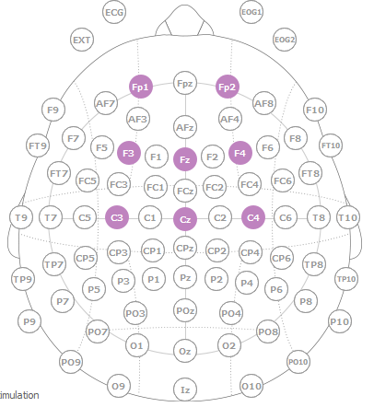

Figure ‎4‑3: A diagram of the 10-20 system for electrode placement for electroencephalography (EEG).

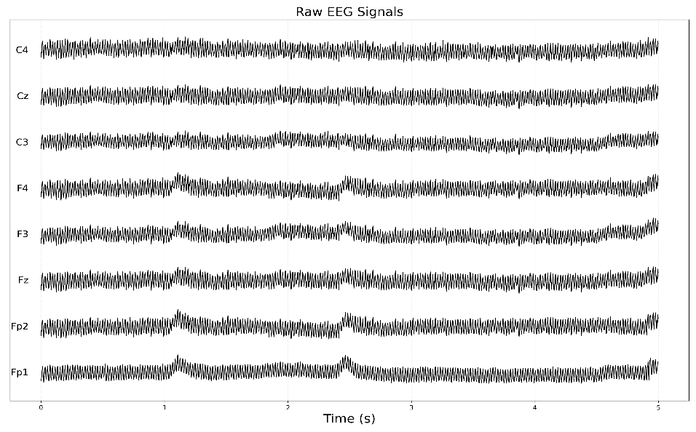The signals were recorded at a sampling rate of 500 Hz, providing sufficient temporal resolution to capture relevant neural dynamics. The EEG data were saved in European Data Format (EDF) files for standardized storage and further processing during the analysis phase. A sample of the raw EEG signals recorded from the selected channels is shown in Figure 4-4, demonstrating the high temporal resolution and signal quality obtained during the recording sessions.

Figure ‎4‑4: Raw EEG signals recorded from 8 channels (Fp1, Fp2, Fz, F3, F4, C3, Cz, and C4) over a 5-second interval.

This protocol provides a balanced and consistent dataset across participants, enabling the investigation of brain network patterns associated with attention and inattention using functional connectivity and graph-theoretical approaches.

## EEG signal processing

The EEG signal processing phase is essential for removing artifacts and enhancing signal quality before feature extraction. This step ensures that the data used for functional connectivity and graph-based analysis is clean, stable, and reflective of true neural activity, as required for accurate attention classification.

The raw EEG signals were first subjected to **bandpass filtering using a Finite Impulse Response (FIR) filter**. The filter was configured to retain frequencies between **1 Hz and 40 Hz**, which encompass the key EEG bands (delta, theta, alpha, beta) known to reflect attentional and cognitive processes. Frequencies below 1 Hz (associated with slow drifts) and above 40 Hz (including muscle artifacts and power-line noise) were attenuated. FIR filters were selected due to their **linear phase property**, which preserves the shape of EEG waveforms a critical aspect in connectivity analysis.

Following filtering, Independent Component Analysis (ICA) will be applied to remove artifacts like eye blinks, muscle activity, and other physiological interferences. ICA decomposes the EEG signal $X\left(t\right)$ into statistically independent components $S(t)$ using a mixing matrix $A$, as described by:

$X\left(t\right)=A∙S(t)$

The components $S(t)$ that correspond to artifacts are identified and removed, leaving only brain-related activity. Figure 4-5 illustrates an example output of ICA step. The scalp map on the left shows the spatial distribution of one identified artifact component (e.g., an eye blink), which is strongly localized in the frontal region. The plot on the right shows the temporal activation of this component across time. Such components are excluded before further analysis to ensure cleaner and more interpretable functional connectivity estimation.

ICA is particularly suited for this project because it effectively separates artifact sources from neural signals, ensuring the features extracted from the data represent true cognitive states rather than noise. Both the Butterworth filter and ICA directly ensuring that the EEG data is clean and relevant, facilitating the reliable detection and classification of attention states, which is the primary objective of this research.

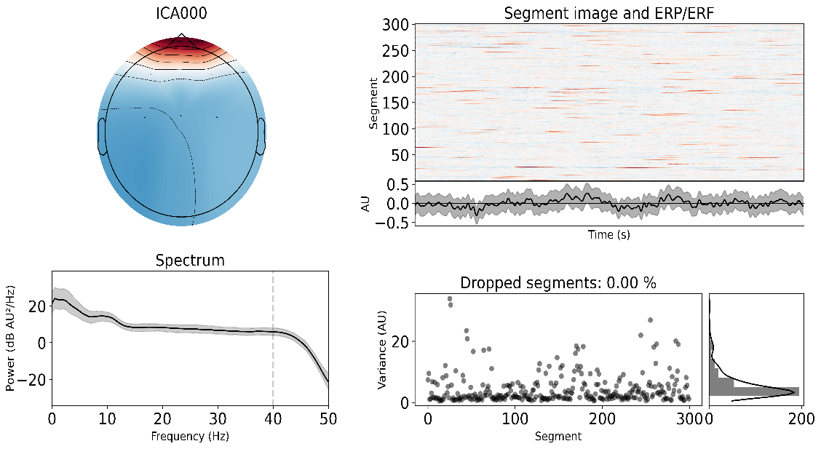

Figure ‎4‑5: Example of an independent component identified as an ocular artifact using ICA. The topographic map shows strong frontal activation consistent with eye blinks, and the time series illustrates its characteristic temporal pattern.

To prepare the EEG data for functional connectivity analysis, the continuous EEG recordings were segmented into overlapping epochs. As illustrated in the graphical representation Figure 4-6, each 10-minute recording from the attention and inattention conditions was divided into 10-second epochs with a 50% overlap, maximizing the number of usable segments while preserving the temporal resolution. For each subject, this segmentation process yielded 119 epochs per condition, with each epoch containing 8 EEG channels and 5,000 time points (based on a 500 Hz sampling rate). The resulting data for each condition had a shape of (epochs, channels, time points) = (~119, 8, 5000).

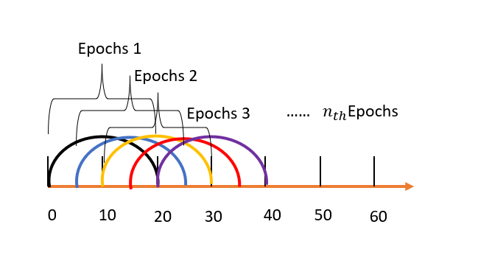

Figure ‎4‑6: Schematic diagram of signal segmentation

## Functional Connectivity Computation

To characterize inter-regional brain communication during attention and inattention states, four functional connectivity measures were computed for each 6-second EEG epoch: **Pearson Correlation (r)**, **Coherence (COH)**, **Directed Phase Lag Index (dPLI)**, and **Mutual Information (MI)**. Each measure reveals a different aspect of brain signal coupling linear, oscillatory, directional, or nonlinear.

Each participant’s EEG recording was segmented into **119 overlapping epochs** per condition. For every epoch, a connectivity matrix of size **8×8** (corresponding to the 8 EEG channels) was computed. Thus, for each connectivity measure and each condition, **a total of 119 connectivity matrices of shape $Epochs ×Channel(i)×Channel(j)=[119, 8, 8]$** were generated per participant.

### Pearson correlation

Pearson correlation is a widely used time-domain metric that quantifies the linear relationship between two signals. For EEG signals X $(t)$ and $Y(t)$ from channels $i$ and $j$ Pearson correlation is computed as:

$$r_{XY}=\frac{\sum_{i=1}^{N}{(X_{i}-\overset{ˉ}{X})(Y_{i}-\overset{ˉ}{Y})}}{\sqrt{\sum_{i=1}^{N}{(X_{i}-\overset{ˉ}{X})^{2}}}\sqrt{\sum_{i=1}^{N}{(Y_{i}-\overset{ˉ}{Y})^{2}}}}$$

Where $X_{i},Y_{i}$ Amplitude values at time point $i$ and $\overset{ˉ}{X},\overset{ˉ}{Y}$ Mean amplitudes of X and Y over all time samples. The resulting matrix is symmetric with values ranging from $-1$ to $1$. A value of +1 represents a strong positive linear relationship, meaning both signals increase proportionally, such as synchronized electrical activity between two frontal electrodes during a focused cognitive task. A value of −1 indicates a strong negative linear relationship, where one signal increases as the other decreases, for instance, an increase in electrical activity in a motor cortex region correlating with a decrease in activity in a sensory processing region during a specific action. A value of 0 reflects no linear relationship between the two signals. Pearson correlation is computationally simple and interpretable, though limited to linear dependencies and sensitive to volume conduction.

### Coherence

Coherence is a frequency-domain measure that evaluates the consistency of amplitude and phase relationships between signals across time. It is defined as:

$${Coh}_{xy}(f)=\frac{∣S_{xy}(f)∣^{2}}{S_{xy}(f)⋅S_{xy}(f)}$$

Where $S_{xy}(f)$ represents the cross-spectral density between the signals at frequency $f$, and $S_{xy}(f)$, $S_{xy}(f)$ are the power spectral densities. Coherence ranges from 0 to 1 and captures synchronization in specific frequency bands. It is especially relevant for attention studies since cognitive processes often modulate oscillatory activity. The coherence matrix is symmetric and frequency-averaged to form a single matrix per epoch.

### Directed Phase Lag Index (dPLI)

The Directed Phase Lag Index (dPLI) is a phase-based measure designed to detect the direction of information flow between EEG signals. Unlike traditional synchrony metrics, dPLI estimates which signal consistently leads or lags in phase, while minimizing the confounding influence of zero-lag synchronization often caused by volume conduction. It is mathematically defined as:

$$dPLI_{XY}=\frac{1}{N}\sum_{k=1}^{N}{I\left(Δ ϕ_{XY} ( t_{k} ) ∈ ( 0 , π )\right)}$$

Where $Δϕ_{XY}(t_{k})$ is the instantaneous phases difference of signals from channels $X$ and $Y$, $I$ is an Indicator function (1 if phase difference in $(0,π)$, else 0). Values close to 0.5 indicate no dominant direction, while deviations from 0.5 suggest leading or lagging phase relationships. A value closer to 1 indicates that signal $X$ consistently leads signal $Y$, while a value closer to 0 indicates that signal $Y$ consistently leads signal $X$. The resulting matrix is inherently asymmetric, capturing directional information flow between regions. dPLI is robust against volume conduction and is particularly useful for identifying directed functional networks, especially in attention studies where cognitive processes often modulate directed oscillatory communication.

### Mutual Information (MI)

Mutual Information (MI) quantifies the amount of shared information between two signals, capturing both linear and nonlinear dependencies. It is mathematically defined as:

$$MI_{XY}=\sum_{x∈X,y∈Y}{p\left(x,y\right)\log\left(\frac{p\left(x,y\right)}{p\left(x\right)p\left(y\right)}\right)}$$

Where $p\left(x\right),p\left(y\right)$ are the marginal probability distributions and $p\left(x,y\right)$ is the joint distribution. The MI matrix is symmetric and non-negative, with higher values indicating greater dependence. Because of its ability to detect complex interactions, MI is particularly suited for cognitive state classification

## Graph Theory and Functional Brain Network Construction

To model the brain’s network structure, each EEG connectivity matrix was converted into a **weighted graph**, $G=(V,E).$ Here, V represents the set of nodes (EEG electrodes) and E is the set of edges (functional connections between electrodes), as shown in Figure 4-11. to reduce noise and highlight meaningful interactions; a proportional thresholding strategy was applied. This method retains only the top X% of the strongest absolute connectivity values, based on a predefined density parameter set to 0.5 for Coherence and 0.4 for dPLI, MI, and Pearson correlation. The diagonal of the matrix (self-connections) was set to zero to prevent self-loops from skewing network metrics. The adjacency matrix $A$ is constructed from the original connectivity matrix $C$ (such as Coherence, dPLI, MI, or Pearson $r$) using the following rule:

$$A_{ij}=\left\{\begin{matrix}C_{ij}, & \text{if }∣C_{ij}∣ >τ\text{ and }i≠j \\ 0, & \text{otherwise}\end{matrix}\right.$$

This process was repeated for each subject, condition, and connectivity type, resulting in **119 graphs per condition per subject**, covering 10 subjects and 4 connectivity types across both attention and inattention states. These graphs form the basis for extracting topological features used in classifying attentional states.

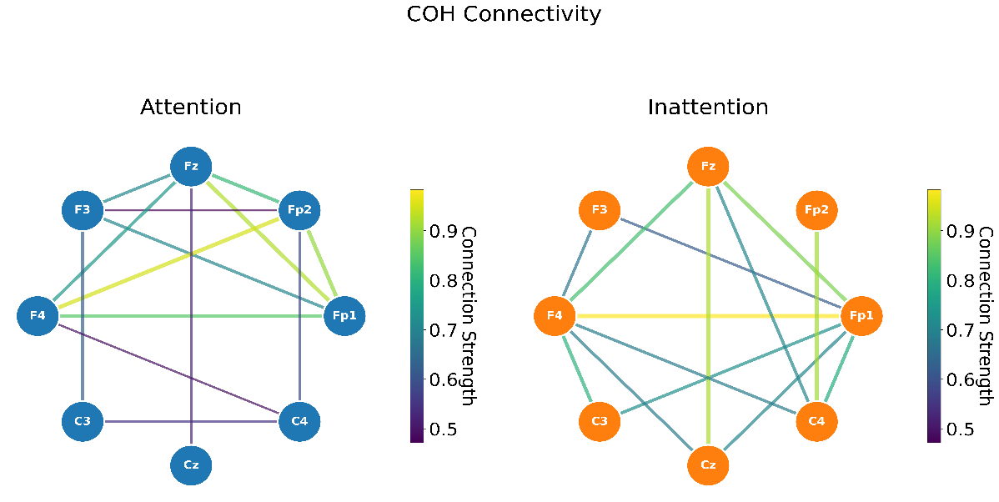

Figure ‑: Thresholded graph representation of Coherence connectivity for Attention (left) and Inattention (right). Edge thickness and colors represent connection strength.

### Graph-Theoretical Feature Extraction

To characterize the topology and dynamics of the brain networks, we extracted a comprehensive set of graph-theoretical features from each connectivity-derived graph. These features were computed for every EEG epoch and across all connectivity types (Coherence, dPLI, MI, and Pearson correlation), resulting in a rich representation of the brain’s functional organization under different cognitive states.

* Static Graph Features

A total of 36 static features were extracted per graph. These features encompass **Basic Structural Properties, Global Topology Metrics, Centrality Measures, Community and Modularity Features, Spectral Features, Core-Periphery Features, Distributional Properties**, and **Robustness Metrics**. These features allow for a multi-scale analysis of each brain network, from individual node connectivity to system-wide integration and modularity, providing discriminative power for attention state classification. For detailed explanations for each static feature, please refer to Appendix A.

* Dynamic Graph Features

In addition to static topology, we extracted 7 dynamic features per graph to capture how the network evolves over time across consecutive epochs. These include **Within-Epoch Metrics** such as edge weight variability and mean edge weight, and **Across-Epoch Changes** like network reconfiguration and temporal differences in average degree and clustering coefficient. These temporal features reflect network flexibility, reorganization, and functional stability, which are hypothesized to vary significantly between attentional and inattentive states. For detailed explanations for each dynamic feature, please refer to Appendix A.

All features were extracted per epoch and stored in a structured format. For missing or undefined values (due to disconnected graphs), we applied NaN-safe practices and later imputed missing values using simple imputation methods where necessary to maintain the consistency of the feature matrix.

### Feature set

Following the extraction of graph-theoretical features from each connectivity-derived graph, a distinct feature matrix was constructed for each subject, per connectivity type, and per attentional condition. For each subject, the 43 extracted graph features (comprising 36 static and 7 dynamic metrics) were concatenated for every individual graph. Given that each subject contributed 119 graphs for the Attention condition and 119 graphs for the Inattention condition, this resulted in feature matrices with a shape of 119 rows by 43 columns for each respective condition and connectivity type per subject. Each row in these matrices represents the comprehensive set of 43 graph features derived from a single EEG epoch's brain network, while each column corresponds to a specific graph-theoretical feature across all epochs for that subject, condition, and connectivity type. Formally, let $S$ be the set of subjects with $∣S∣=10$, $C$ the set of connectivity types such that $C=\{\text{Coherence},\text{dPLI},\text{MI},\text{Pearson’s }r\}$ with $∣C∣=4$ and $K=\{\text{Attention},\text{Inattention}\}$ the set of attentional conditions with $∣K∣=2$ For each subject $s∈S$, connectivity type $c∈C$, and condition $k∈K$, the feature matrix $X_{s,c,k}∈R^{119×43}$ is constructed, where each row corresponds to an EEG epoch's brain network features labeled implicitly by $k$. Concatenating the feature matrices across both attentional conditions for a given subject and connectivity type yields $X_{s,c}=\left[\begin{aligned}X_{s,c,\text{Attention}} \\ X_{s,c,\text{Inattention}}\end{aligned}\right]∈R^{238×43}$ with a corresponding label vector $Y_{s,c}∈K^{238}$ that specifies the condition of each epoch. Finally, aggregating data across all subjects and connectivity types forms the total dataset feature matrix $X_{\text{total}}∈R^{2380×172}$ where $2380=∣S∣×119×∣K∣=10×119×2$, with an associated label vector $Y_{\text{total}}∈K^{2380}$ indicating the attentional state for each graph.

## Feature Analysis Using Statistical Testing (t-test)

To evaluate whether the extracted graph-based features are truly discriminative between attention and inattention states, a two-sample independent t-test was conducted. For each feature, values across all subjects were grouped according to cognitive state, and their distributions were statistically compared. The t-test quantifies whether the means of the two conditions differ significantly. The test statistic is given by:

$$t=\frac{{\overset{ˉ}{x}}_{1}-{\overset{ˉ}{x}}_{2}}{\sqrt{\frac{s_{1}^{2}}{n_{1}}+\frac{s_{2}^{2}}{n_{2}}}}$$

Where ${\overset{ˉ}{x}}_{1}$ and ${\overset{ˉ}{x}}_{2}$ are the mean feature values under attention and inattention respectively, $s_{1}^{2}$ and $s_{2}^{2}$ are the sample variances, and $n_{1}$, $n_{2}$ are the number of samples in each group. Prior to analysis, all features were z-score normalized and missing values were imputed using the mean to ensure fair comparison.

To account for the multiple hypothesis tests performed across features, the Bonferroni correction was applied to adjust the significance threshold. Features with adjusted p-values below 0.05 were considered statistically significant, indicating a reliable difference between attention and inattention.

In addition to significance, the practical magnitude of these differences was quantified using Cohen’s d, which captures effect size. It was calculated as:

$$d=\frac{{\overset{ˉ}{x}}_{1}-{\overset{ˉ}{x}}_{2}}{s_{p}} \text{where} s_{p}=\sqrt{\frac{(n_{1}-1)s_{1}^{2}+(n_{2}-1)s_{2}^{2}}{n_{1}+n_{2}-2}}$$

With $s_{p}$ representing the pooled standard deviation. Positive values of $d$ indicate higher feature values during attention, while negative values imply stronger expression during inattention. This statistical testing framework ensures that the retained features are not only mathematically robust but also meaningful in distinguishing between cognitive states.

## Classification Framework: Subject-Dependent and Subject-Independent Models

To evaluate the discriminative power of the extracted graph-based EEG features in distinguishing attentional states, both **subject-dependent** and **subject-independent** classification paradigms were implemented using a comprehensive machine learning framework.

### Classification Paradigms

In the **subject-independent** setting, a **Leave-One-Subject-Out (LOSO)** cross-validation strategy was used. For each iteration, data from one subject served as the test set, while the remaining subjects' data were used for training. This approach rigorously assesses the generalizability of the models to unseen individuals and simulates real-world inter-subject application.

In contrast, the **subject-dependent** classification employed **Stratified K-Fold Cross-Validation** within each subject using k= 2 folds. This assesses how well the model performs on a specific individual by training and testing on disjoint epochs from the same subject.

The feature matrix used for classification was the concatenation of static and dynamic graph features across four connectivity measures: **Coherence (COH), Directed Phase Lag Index (DPLI), Mutual Information (MI), and Pearson correlation (r)**.

### Preprocessing Pipeline and Feature Selection

A strict within-fold preprocessing protocol was enforced to prevent data leakage, ensuring that all transformations were derived exclusively from training data before application to the test set. The pipeline consisted of four sequential steps:

1. Missing Value Imputation: Missing entries were replaced with the training set’s feature-wise mean. For a feature $x$ the imputed value ${\hat{x}}_{i}$ is:

$${\hat{x}}_{i}=\overset{ˉ}{x}=\frac{1}{n}\sum_{j=1}^{n}{x_{j}}$$

where $n$  is the number of observed values for $x$  in the training set.

1. Normalization:

Features were standardized via Z-score scaling StandardScaler, with mean $μ$ and standard deviation $σ$  computed from the training data:

$$z_{i}=\frac{x_{i}-μ}{σ}$$

1. Variance Thresholding:

Low-variance features were discarded using VarianceThreshold= $1×{10}^{-5}$ to eliminate non-informative predictors.

1. Feature Selection:

A two-sample t-test identified features significantly differing ($p<0.05$) between attentional states. If none met this threshold, the top 10 features with smallest p-values were retained.

### Model Selection and Hyperparameter Optimization

Nine classifiers were evaluated, spanning linear models, ensemble methods, neural networks, kernel-based, and probabilistic approaches. Hyperparameters were optimized via RandomizedSearchCV with 3-fold internal cross-validation, where the number of iterations (n_iter) was adaptively set based on the search space size to balance computational efficiency and exploration. Table 4-2 summarizes the models, their theoretical strengths/weaknesses, and hyperparameter search spaces.

Table ‎4‑2: Model comparison for attentional state classification

|  |  |  |  |  |
| --- | --- | --- | --- | --- |
| **Model** | **Type** | **Advantages** | **Limitations** | **Hyperparameters** |
| Logistic Regression | Linear | Interpretable, supports elasticnet penalties | Limited to linear decision boundaries | C: [0.001, 0.01, 0.1, 1] penalty: ['l1','l2','elasticnet'] solver: ['saga'] l1_ratio: [0.1,0.5,0.9] |
| SGD Classifier | Linear | Memory-efficient, online learning capability | Requires careful hyperparameter tuning | loss: ['hinge','log_loss','modified_huber'] penalty: ['l1','l2','elasticnet'] alpha: [0.0001,0.001,0.01] |
| Random Forest | Ensemble | Robust to noise and outliers | Slower prediction times | n_estimators: [100,200] max_depth: [None,10,20] min_samples_split: [2,10] |
| Extra Trees | Ensemble | Faster training than Random Forest | Slightly higher variance | n_estimators: [100,200] max_depth: [None,20] min_samples_leaf: [1,4] |
| Gradient Boosting | Ensemble | Strong predictive performance | Sensitive to overfitting | n_estimators: [100] learning_rate: [0.05,0.1] max_depth: [3,5] |
| XGBoost | Ensemble | Handles missing data, regularization | Complex parameter interactions | n_estimators: [100,200] max_depth: [3,6] gamma: [0,0.2] |
| SVM (RBF) | Kernel-based | Effective in high-D spaces | Poor scalability to large datasets | C: [0.1,1] gamma: ['scale',0.1] |
| MLP | Neural Network | Universal function approximation | Requires extensive tuning | hidden_layer_sizes: [(100,),(150,),(100,50)] activation: ['relu','tanh'] |
| Gaussian NB | Probabilistic | Extremely fast training | Strong feature independence assumption | var_smoothing: [1e-9,1e-7] |

### Performance Evaluation and Metrics

To evaluate the effectiveness of the classifiers in distinguishing between attention and inattention states, three primary performance metrics were employed: accuracy, F1-score, and the area under the receiver operating characteristic curve (ROC AUC). Each metric offers a different perspective on classification quality, enabling a comprehensive assessment of model behavior across both subject-dependent and subject-independent scenarios.

Accuracy measures the proportion of correctly classified instances out of the total number of samples and is given by:

$$\text{Accuracy}=\frac{TP+TN}{TP+TN+FP+FN}$$

Where $TP$ and $TN$ represent the number of true positives and true negatives, respectively, and $FP$ and $FN$ denote the number of false positives and false negatives.

To account for class imbalance and provide a harmonic balance between precision and recall, the F1-score was computed. The F1-score is defined as:

$$\text{F1-score}=2⋅\frac{\text{Precision}⋅\text{Recall}}{\text{Precision}+\text{Recall}}$$

where precision is given by $\text{Precision}=\frac{TP}{TP+FP}$ and recall by $\text{Recall}=\frac{TP}{TP+FN}$ This metric is particularly informative in scenarios where the cost of false positives and false negatives is asymmetric, as it penalizes extreme values of either precision or recall.

The ROC AUC score quantifies the model’s ability to discriminate between classes across different threshold settings. It represents the probability that the classifier ranks a randomly chosen positive instance higher than a randomly chosen negative one. The ROC curve itself plots the true positive rate (TPR) against the false positive rate (FPR), where:

$$\text{TPR}=\frac{TP}{TP+FN}, \text{FPR}=\frac{FP}{FP+TN}$$

and the ROC AUC is the area under this curve, computed using the trapezoidal rule. A value of 0.5 indicates random performance, while a value of 1.0 corresponds to perfect classification. For subject-independent evaluation, a Leave-One-Subject-Out (LOSO) cross-validation framework was used, in which the model was trained on all but one subject and tested on the excluded subject. The reported metrics were averaged across all LOSO folds. For subject-dependent evaluation, a Stratified K-Fold cross-validation strategy was applied within each subject using $k=2$ folds, and results were averaged across folds and then across subjects. This dual validation design allowed the study to assess both generalizability across individuals and specialization within individual cognitive patterns.

## Conclusion

This chapter presented a robust methodology for EEG-based attention detection using graph signal processing. EEG signals were recorded under two cognitive conditions and processed into functional connectivity matrices (COH, DPLI, MI, Pearson’s r), which were converted into graphs for extracting static and dynamic features. A careful preprocessing pipeline including imputation, normalization, variance filtering, and t-test-based feature selection ensured data integrity and minimized leakage. Classification was performed using both subject-dependent and subject-independent setups, leveraging a diverse set of machine learning models with hyperparameter tuning. Together, these steps form a scalable and generalizable framework for classifying attentional states, laying the groundwork for real-world cognitive monitoring applications.

# 

# Results and Discussions

This chapter presents and discusses the results obtained from the EEG-based attention detection framework described in Chapter 4. It is structured in alignment with the study’s objectives and methodological design. Firstly, we present findings related to power spectral density (PSD) measures, specifically focusing on the Theta/Beta ratio, a well-established biomarker for attention and cognitive state. Following this, we compute functional connectivity matrices and extract graph features. Next, we examine the statistical analysis of extracted graph-theoretical features to determine their discriminative power in distinguishing between attentional and inattention states. This includes a detailed t-test analysis across four connectivity measures: Coherence (COH), Directed Phase Lag Index (DPLI), Mutual Information (MI), and Pearson correlation (r). Finally, classification performance is reported and compared across both subject-dependent and subject-independent paradigms using a suite of machine learning classifiers. The results are interpreted in the context of existing literature to assess their consistency with known cognitive neuroscience findings and to explore the practical implications of EEG modeling for real-time attention monitoring.

## Analysis of Theta/Beta Ratio in Frontal Electrodes

Beyond functional connectivity, power spectral density (PSD) measures in specific frequency bands offer valuable insights into brain states related to attention and cognitive load. This section presents the analysis of Theta (θ: 4-8 Hz) and Beta (β: 12-30 Hz) band power, and their derived ratio (Theta/Beta ratio), specifically across key frontal electrodes (Fp1, Fp2, Fz, F3, F4). This ratio is a widely explored biomarker for alertness, cognitive effort, and attention regulation, with a lower ratio typically associated with increased focus. For each participant, EEG data, pre-processed with ICA and filtering (as detailed in Chapter 4), was utilized, with power in these bands computed using Welch's method and then averaged across the specified frontal electrodes. As visually depicted in the Power Spectral Density (PSD) plot for Subject S01 (Figure 5-1), the attention state (blue line) consistently exhibits higher power compared to the inattention state (orange line) across the relevant frequency spectrum. More specifically, within the Beta band (12-30 Hz, orange shaded area), the power in the attention state is markedly elevated compared to inattention, suggesting a pronounced increase in active cortical processing. While Theta band power (4-8 Hz, purple shaded area) also shows an increase during attention, the relative increase in Beta power is proportionally greater. This dynamic leads to a visibly lower Theta/Beta ratio in the attention state, reflecting a shift towards higher-frequency activity. This pattern a decrease in the Theta/Beta ratio alongside increased Beta activity during attention strongly aligns with findings from numerous studies in the neurofeedback and cognitive neuroscience literature, which consistently report that a lower frontal Theta/Beta ratio is associated with improved sustained attention and reduced mind-wandering [60].

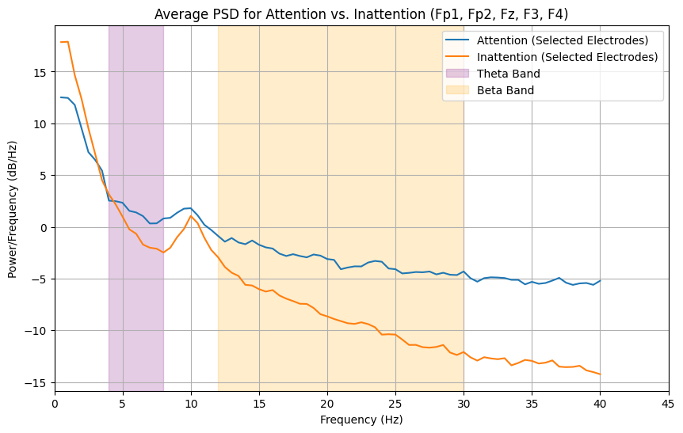

Figure ‑: Average Power Spectral Density (PSD) for Attention versus Inattention across selected frontal electrodes (Fp1, Fp2, Fz, F3, F4). Shaded areas represent Theta (4-8 Hz, purple) and Beta (12-30 Hz, orange) frequency bands.

## Functional connectivity computation result

As shown in Figure 5-1 a heatmap of average Pearson R connectivity across "Attention Condition" and "Inattention Condition." Each cell in the heatmap represents the average Pearson R value between a pair of EEG electrodes. For instance, in the "Attention Condition" heatmap, the bright yellow squares along the diagonal (e.g., Fp1-Fp1, Fz-Fz) indicate a perfect positive correlation of 1.0, as expected for a signal correlated with itself. Observing off-diagonal elements, a bright yellow cell like the one potentially between Fz and F3 suggests a strong positive correlation, meaning their electrical activities tend to rise and fall together. Conversely, a darker purple cell, if present, would indicate a negative correlation, where an increase in activity in one region is typically accompanied by a decrease in the other. By comparing the patterns of yellow and purple across the "Attention Condition" and "Inattention Condition" heatmaps, one can visually identify how the strength and direction of these inter-regional relationships change depending on the attentional state. For example, if a specific connection (Fz-F3=0.52) shows a stronger positive correlation in the "Attention Condition" compared to a weaker correlation (Fz-F3=0.23) in the "Inattention Condition," it suggests that this particular brain region pair becomes more synchronously active when attention is engaged."

Such patterns reinforce the neurophysiological interpretation that attention is associated with enhanced inter-regional synchronization, especially across task-relevant regions[61]. However, because Pearson correlation is sensitive to volume conduction and only captures linear dependencies, it is most valuable when interpreted in combination with other, more specific connectivity measures.

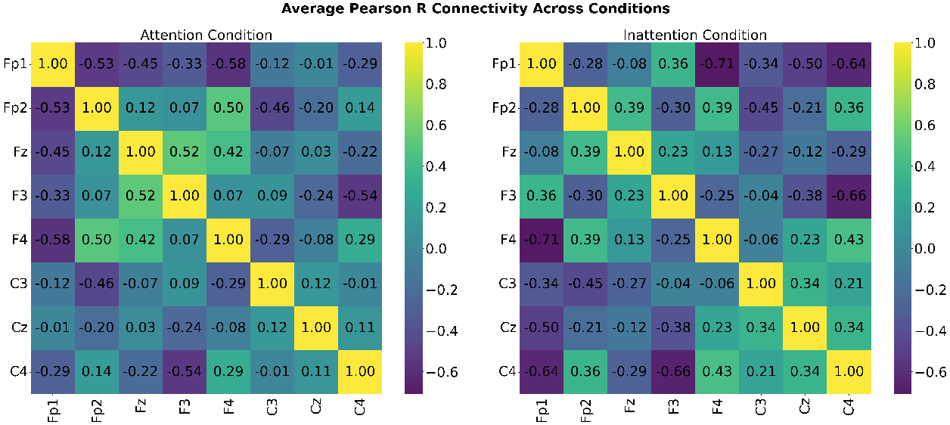

Figure ‑:Average Pearson R Connectivity by ConditionHeatmaps illustrate average Pearson R values between EEG channels for (Left) Attention and (Right) Inattention. Warm (yellow) and cool (purple) colors denote positive and negative correlations, respectively.

A representative heatmap of an averaged coherence matrix is shown in Figure5-2, comparing the Attention Condition and Inattention Condition. Each cell in the heatmap reflects the average coherence between a specific pair of EEG electrodes. As seen in the figure, most coherence values decrease in the inattention state, especially across frontal and fronto-central pairs such as Fp1–Fp2, Fp2–F4, and Fz–F3. For instance, Fp1–Fp2 coherence drops from 0.70 in the attention condition to 0.57 during inattention, while Fz–F3 decreases from 0.66 to 0.51.This pattern supports findings in the literature suggesting that attention is associated with increased neural synchronization in task-relevant networks[62]. Interestingly, a localized increase in coherence was observed between F3 and C4, rising from 0.56 (attention) to 0.64 (inattention). While this deviates from the general trend of reduced coherence, such an increase may reflect a functional reorganization of brain networks during inattention. This reorganization could involve greater activation of internally directed or task-irrelevant networks, such as the Default Mode Network (DMN), which is known to become more active when external attention wanes and the brain shifts toward self-referential or internally focused thought processes. Such findings align with studies suggesting that during passive or resting states, connectivity patterns shift to support stimulus-independent cognition rather than focused external engagement[63].

These coherence-based comparisons demonstrate the measure’s effectiveness in distinguishing neural states, highlighting its utility in attention classification frameworks.

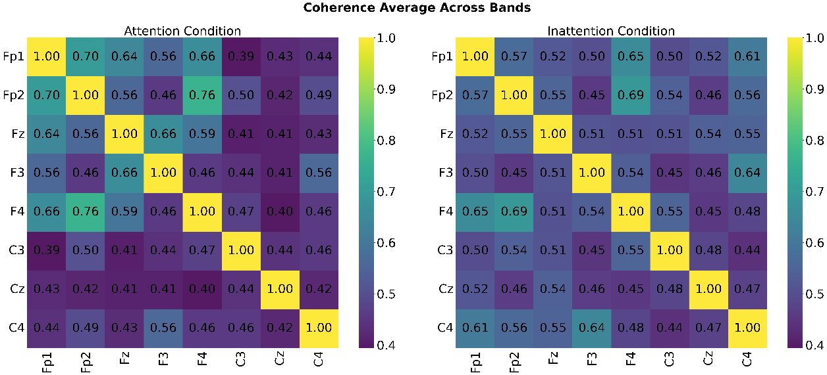

Figure ‑: Average Coherence Connectivity Heatmaps display average coherence values for EEG electrode pairs during (Left) Attention and (Right) Inattention Conditions. Warmer colors (yellow) indicate higher synchronization, while cooler colors (purple) indicate lower synchronization. The diagonal represents self-coherence (1.0).

A representative heatmap of an averaged dPLI matrix is shown in Figure 4-9, comparing the Attention Condition and Inattention Condition. Each cell in the heatmap reflects the average dPLI between a specific pair of EEG electrodes. Unlike the highly symmetric averaged correlation or coherence matrices, these dPLI matrices prominently display asymmetry and values that significantly deviate from 0.5, indicating robust and consistent directed phase-lagging relationships.

As seen in Figure 5-3, specific directed pathways exhibit notable shifts between the Attention and Inattention states. For instance, the dPLI from (Fp1, F4) left prefrontal to left frontal is 0.63 in the Attention Condition, indicating a strong leading influence from Fp1 to F4. This lead significantly weakens to 0.49 in the Inattention Condition, suggesting a reduction in this specific frontal drive when attention wanes. Conversely, the dPLI from (Fp2, Fp1) right prefrontal to left prefrontal increases from 0.48 in Attention to a stronger lead of 0.56 in Inattention. This pattern suggests a reorganization of directed information flow between conditions, with some pathways becoming less dominant and others becoming more prominent. This observed pattern supports findings in the literature suggesting that attention is associated with dynamic and specific modulations of directed neural information flow within task-relevant networks[64]. These dPLI-based comparisons demonstrate the measure's effectiveness in distinguishing neural states by revealing the underlying directional communication, highlighting its utility in attention classification frameworks.

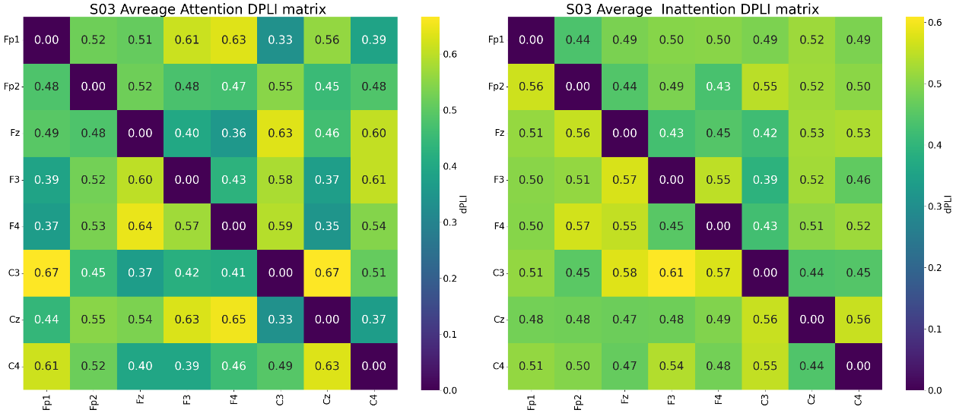

Figure ‑: Average dPLI Connectivity Across Conditions. Heatmaps show averaged Directed Phase Lag Index (dPLI) between EEG electrode pairs for Attention (left) and Inattention (right). Values from 0.4 to 0.6 indicate directionality: >0.5 means row leads column, <0.5 means column leads row. This reveals asymmetric, directed information flow.

A sample averaged MI matrix is shown as a heatmap in Figure 4-10, comparing the Attention Condition and Inattention Condition. Each cell in the heatmap reflects the average mutual information between a specific pair of EEG electrodes.

As seen in Figure 5-4, the MI values generally reflect moderate to low shared information, with specific pairs showing stronger dependencies. In the Attention Condition, notable MI values are observed for fronto-central pairs such as Fp2–F4 0.54 and Fp1–F4 0.28. In the Inattention Condition, these fronto-frontal and fronto-central connections exhibit a marked increase in shared information. For instance, Fp2–F4 MI rises significantly from 0.54 in Attention to 0.65 during Inattention. Similarly, Fp1–F4 MI increases from 0.28 (Attention) to 0.560 (Inattention). Other pairs, like F3–C4, also show an increase, from 0.27 (Attention) to 0.46 (Inattention).

This pattern, where fronto-frontal and fronto-central mutual information tends to increase in the inattention state, supports findings in the literature suggesting a reorganization of functional brain networks during periods of reduced externalattention. Such an increase in MI, particularly in frontal regions, may reflect the greater activation and internal processing within intrinsic brain networks, suchas the DefaultMode Network (DMN), which is known to become more active when external attention decreases and the brain shifts toward self-referential or internally focused thought processes. These findings align with studies suggesting that during passive or resting states (which can be analogous to unconstrained inattention), connectivity patterns shift to support stimulus-independent cognition rather than focused external engagement[65].These MI-based comparisons demonstrate the measure’s effectiveness in distinguishing neural states by capturing complex interdependencies, highlighting its utility in attention classification frameworks.

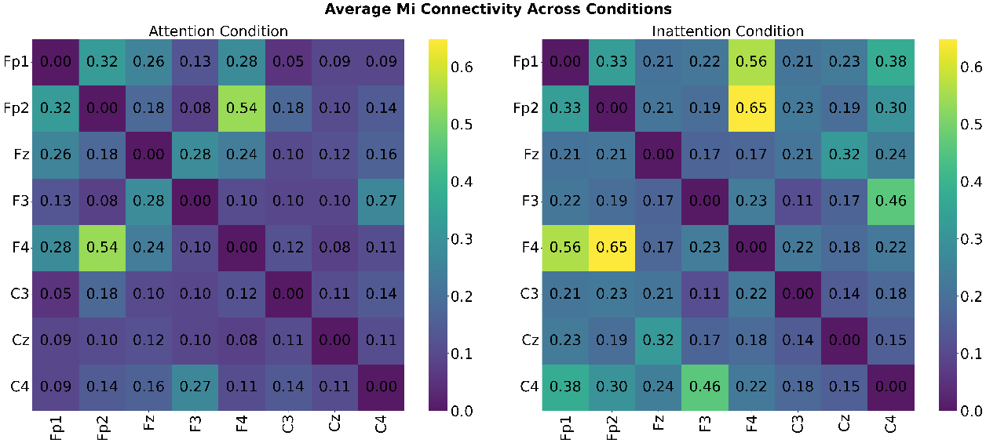

Figure ‑: Average MI Connectivity Across Conditions. Heatmaps show averaged Mutual Information (MI) between EEG electrode pairs for Attention (left) and Inattention (right) conditions. Values (0.0-0.65) indicate shared information; higher values mean greater dependence.

## Feature Analysis Results

To identify statistically discriminative features between attention and inattention states, Welch’s two-sample t-tests were performed independently for each of the 43 graph-based features extracted from each connectivity matrix (COH, DPLI, MI, and Pearson correlation). A Bonferroni correction was applied to control for multiple comparisons, with corrected significance thresholds set at α = 0.05 / 43 ≈ 0.00116.

The total number of statistically significant features (after Bonferroni correction) for each connectivity method is as follows:

* **COH (Coherence):** 25 out of 43 features
* **DPLI (Directed PLI):** 21 out of 43 features
* **MI (Mutual Information):** 31 out of 43 features
* **Pearson Correlation:** 29 out of 43 features

Extremely small p-values (p < 0.001) were observed across multiple connectivity types, particularly for graph strength-related features (total weight, avg weight, min weight), closeness centrality, global efficiency, and dynamic metrics such as edge weight variability and reconfiguration indices.

### Key Findings Across All Connectivity Measures

1. Increased Global Efficiency During Attention
   * COH, MI, and Pearson showed higher global efficiency. This suggests an enhanced capacity for information integration across these specific connectivity measures during attention[66].
2. Reduced Average Edge Weights in Attention
   * Despite increased efficiency, attention was associated with lower average connectivity weights, minimum edge weights, and total network strength.
3. Higher Closeness Centrality in Attention
   * Hub regions showed enhanced closeness centrality, suggesting prioritized information transfer during attention, indicating more efficient information propagation. This supports the idea that attention strengthens the influence of central nodes in functional networks.
4. Dynamic Network Reconfiguration
   * Features related to network flexibility, such as edge weight variability and reconfiguration indices, were significantly different between states, suggesting that attention involves adaptive rewiring of functional connections.This supports the "network reconfiguration" hypothesis of attention[67].

### Measure-Specific Findings

1. Coherence (COH) Network Properties

As shown in Figure 5-5, the COH analysis reveals a fundamental reorganization of phase-synchronized networks during attentional states. The observed reduction in largest component ratio (p=2.8043e-12, Attention < Inattention), despite being counterintuitive, aligns with Smith et al[68]. model of selective network integration in EEG systems. This pattern suggests that effective attention involves strategic disconnection of task-irrelevant pathways rather than global activation increases. The simultaneous increase in global efficiency(p=3.8623e-70, Attention > Inattention ) supports Bassett and Bullmore's [69] small-world optimization hypothesis, where the brain achieves greater functional integration through selective pruning. These findings collectively suggest that phase-synchronized networks undergo selective pruning of phase-synchronized connections, prioritizing quality over quantit*y* during attention, where connection quality supersedes quantity.

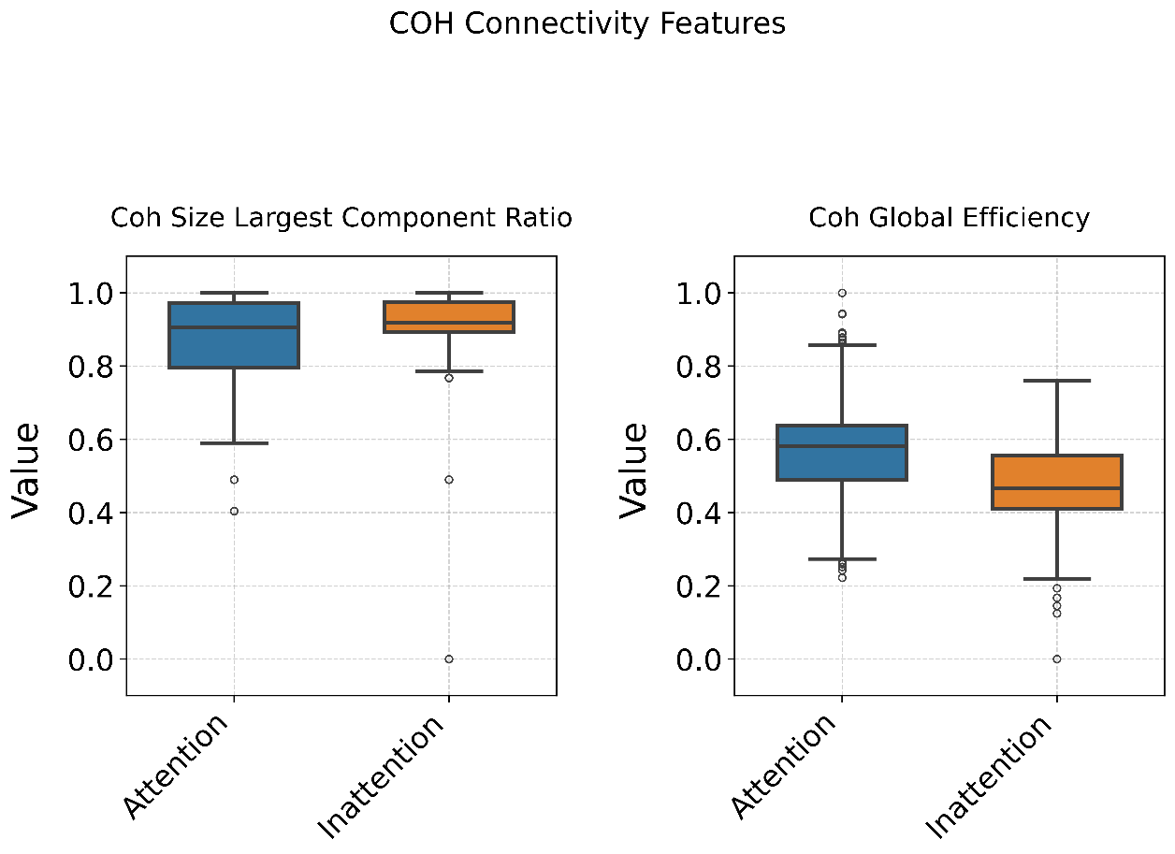

Figure ‑:Coherence (COH) network features during attention (blue) and inattention (orange) states. Left Size of largest component ratio reflects network integration, with lower values indicating more fragmented organization. Right Global efficiency measures information transfer capacity, where higher values suggest more optimized routing.

1. Directed Phase Lag Index (DPLI) Network Properties

As shown in Figure 5-6, the DPLI results provide compelling evidence for directionally-specific network reconfiguration during attention. The increased betweenness centrality (p=1.1717e-09, Attention > Inattention) supports Gratton et al. [70] model of enhanced hub-mediated routing in cognitive tasks. This directional specialization is further evidenced by the reduced Gini coefficient (p=4.5209e-23, Attention < Inattention), which aligns with Zalesky et al. [71] observations of more balanced network configurations during goal-directed states. The modifications in algebraic connectivity(p=5.4310e-07, Attention < Inattention) particularly reflect Mišić et al[72] dynamical systems approach to network stability. These directional changes underscore the importance of information routing dynamics in supporting attentional processes, beyond simple connection strength modifications.

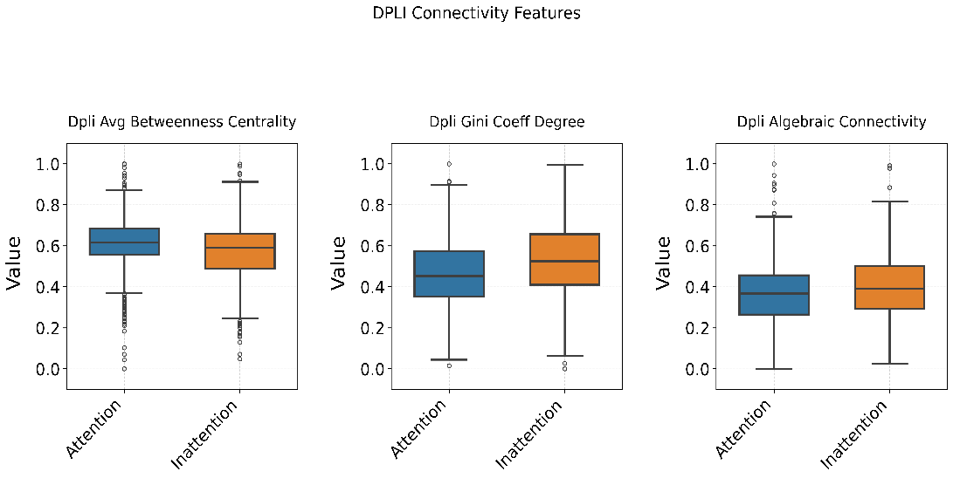

Figure ‑:Directed Phase Lag Index (DPLI) network topology features. Left Betweenness centrality identifies hub regions critical for information flow. Middle Gini coefficient quantifies degree distribution equality (0=uniform, 1=unequal). Right Algebraic connectivity reflects network robustness.

1. Mutual Information (MI) Network Properties

As shown in Figure 5-7, the MI results demonstrate how attention fundamentally alters nonlinear information integration. The exceptionally strong global efficiency (p=2.9498e-199, Attention > Inattention) effects support Lynall et al.[73] emphasis on nonlinear interactions in cognitive processing. The pronounced changes in closeness centrality (p=4.7254e-251, Attention > Inattention) align with Gu et al.[74] findings about dynamic hub reorganization during attention.

These nonlinear effects are particularly significant because they capture higher-order dependencies that linear methods cannot detect, consistent with Deco et al.[75] information-theoretic framework. The results position mutual information as a sensitive metric for capturing the rich dynamics underlying attentional network reconfiguration.

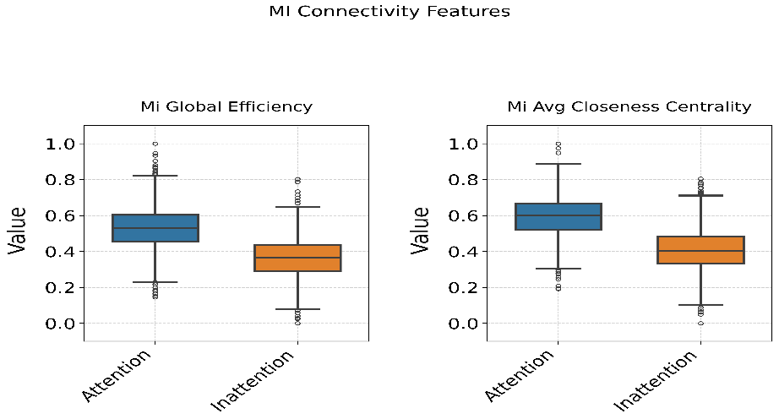

Figure ‑:Mutual information (MI) network characteristics comparing cognitive states. Left Global efficiency captures nonlinear information integration capacity. Right Closeness centrality reveals nodes with shortest paths to others, indicating efficient communication hubs.

1. Pearson Correlation Connectivity Network Properties

As shown in Figure 5-8, The Pearson correlation results reveal stable architectural foundations for attention dynamics. The preserved closeness centrality (p=8.4129e-173, Attention > Inattention) patterns confirm Power et al.[76] observations about stable hub architecture across cognitive states. The unique weight distribution patterns particularly reflect Olshausen and Field [77] sparse coding principles in neural systems. These linear patterns provide crucial context for interpreting more dynamic effects observed through other connectivity measures.

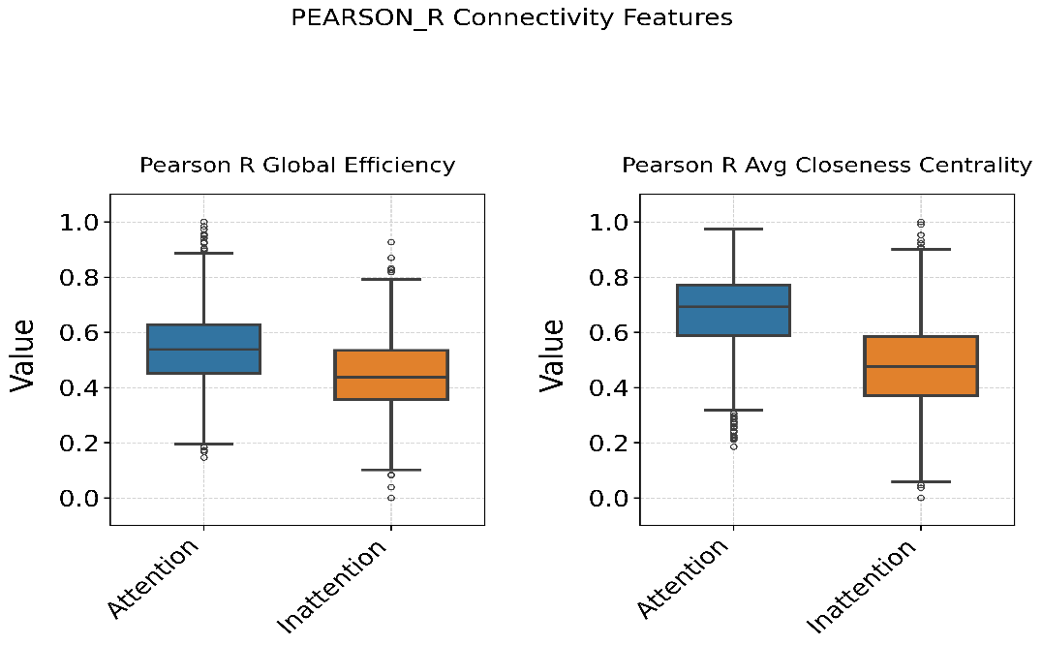

Figure ‑:Linear correlation (Pearson r) network properties. Left Global efficiency of linear connections forms the structural backbone. Right Closeness centrality of linearly correlated nodes shows stable hub architecture.

The comparative analysis reveals distinct network signatures characterizing attentive and inattentive states. During inattention, neural networks exhibit increased connection density yet demonstrate reduced efficiency, manifesting as stronger but less organized connectivity patterns with predominant local clustering over global integration. Conversely, attentive states display optimized network architecture marked by enhanced global efficiency, strengthened hub connectivity, and improved information routing capacity. This fundamental reorganization suggests attention operates through selective connection pruning and dynamic reconfiguration, transitioning from a diffusely connected "high-noise" state to a streamlined system prioritizing critical pathways. The consistent emergence of these patterns across multiple connectivity measures underscores attention's role in modulating both the structure and functional capacity of brain networks to support goal-directed cognition.

## Classification Results

To evaluate the discriminative capacity of the extracted EEG graph-based features, both subject-dependent and subject-independent classification schemes were implemented across a broad range of machine learning models. Classification was performed using a concatenated feature set derived from four functional connectivity measures: Coherence (COH), Directed Phase Lag Index (DPLI), Mutual Information (MI), and Pearson correlation. The classification performance was assessed using accuracy, F1-score, and area under the receiver operating characteristic curve (ROC AUC), ensuring a comprehensive evaluation of both predictive power and class discrimination.

### Subject-Dependent Classification

The subject-dependent framework involved stratified 2-fold cross-validation applied individually to each subject, with training and testing performed on disjoint subsets of that subject's data. This paradigm captures within-subject variability and is suitable for evaluating model performance in a personalized setting. Overall, the results demonstrated exceptional classification performance across all models, with mean accuracies exceeding 97% and average F1-scores consistently above 0.97. Logistic Regression and SGD Classifier each achieved an average accuracy of 99.24% with F1-scores of 0.99, and perfect ROC AUC scores of 1.00. Similarly, ensemble methods such as Extra Trees (99.16% ± 1.08%) and Gradient Boosting (99.08% ± 0.90%) exhibited robust performance. Neural networks (MLP) and kernel-based models (SVM) also performed admirably, with accuracies of 98.36% and 98.82%, respectively, and AUC scores nearing or reaching 1.00. Despite their simplicity, even probabilistic models such as Gaussian and Bernoulli Naive Bayes maintained competitive performance, achieving accuracies of 97.73% and 97.23%, respectively. These results indicate that the extracted connectivity-based features are highly discriminative when trained and tested on the same subject, likely reflecting strong individual-specific neural signatures related to attention. The hyperparameter configurations most frequently selected during this evaluation are summarized in Table 5.1.

Table ‎5‑1: Most Frequently Selected Hyperparameters – Subject-Dependent Classification

|  |  |
| --- | --- |
| **Classifier** | **Most Frequent Hyperparameters Selected** |
| Logistic Regression | solver: saga penalty: l2 l1_ratio: 0.1 or 0.5 C: 0.01 or 0.1 max_iter: 1000 |
| SGD Classifier | penalty: l1 / elasticnet loss: log_loss or hinge learning_rate: constant / adaptive eta0: 0.01 or 0.1 alpha: 0.01 l1_ratio: 0.7 |
| MLP | solver: adam activation: relu (mostly) or tanh (S04) hidden_layer_sizes: (100,), (150,), or (100, 50) alpha: 0.001 or 0.01 learning_rate_init: 0.0001 or 0.001 |
| Random Forest | n_estimators: 200 min_samples_split: 2 or 10 min_samples_leaf: 1 or 4 max_depth: 10, 20, or None max_features: sqrt criterion: gini |
| Extra Trees | n_estimators: 100 or 200 min_samples_split: 2 or 10 min_samples_leaf: 1 or 4 max_depth: 20 or None max_features: sqrt or None |
| Gradient Boosting | n_estimators: 100 learning_rate: 0.05 or 0.1 max_depth: 3 or 5 subsample: 0.8 or 1.0 max_features: sqrt |
| XGBoost | n_estimators: 100 or 200 learning_rate: 0.05 or 0.1 max_depth: 3 or 6 subsample: 0.8 or 1.0 reg_alpha: 0 or 0.1 reg_lambda: 0.1 or 1 gamma: 0 or 0.2 colsample_bytree: 0.8 or 1.0 |
| SVM (RBF) | |  | | --- | |  |  |  | | --- | | kernel: rbf gamma: scale C: 1,2,3 | |

### Subject-Independent Classification (Leave-One-Subject-Out)

To evaluate generalization to unseen individuals, a leave-one-subject-out (LOSO) cross-validation strategy was adopted. In each iteration, one subject’s data was held out for testing, while the remaining subjects formed the training set. This design emulates real-world application scenarios where models must adapt to inter-subject variability.

As expected, performance in the LOSO setup was slightly reduced compared to subject-dependent classification due to inherent individual differences in EEG signals. The Support Vector Machine (SVM) classifier achieved the highest average accuracy of 83.91% ± 16.02% and an F1-score of 0.83, with a ROC AUC of 0.89, indicating strong generalizability. MLP, Extra Trees, and XGBoost followed closely with accuracies exceeding 82% and AUC values ranging from 0.88 to 0.89. Logistic Regression, Gradient Boosting, and SGD also maintained competitive performance, with average accuracies around 80% and F1-scores above 0.80.

Although Gaussian Naive Bayes demonstrated relatively lower performance (77.31% ± 16.14% accuracy), its ROC AUC of 0.84 suggests that even simple probabilistic models can offer meaningful class separability under inter-subject conditions.

These results confirm that the fused graph-based features extracted from multiple functional connectivity measures retain inter-subject discriminability, enabling the development of generalized attention detection models that extend beyond individual-specific training data. The most frequently selected hyperparameters during LOSO classification are summarized in **Table 5.2**, reflecting consistent patterns in model configuration that align with literature recommendations. Additionally, the **learning curve plot** (Figure 5-9) illustrates stable convergence behavior and suggests that increased training data consistently improves generalization, further supporting the scalability of the proposed framework. A comparative visualization of average LOSO accuracy across all evaluated classifiers is provided in the radar plot (Figure 5-10), offering an intuitive overview of model-level performance differences.

Table ‎5‑2: Most Frequently Selected Hyperparameters – Subject-Independent (LOSO) Classification

|  |  |
| --- | --- |
| **Classifier** | **Most Frequent Hyperparameters Selected** |
| Logistic Regression | |  | | --- | |  |  |  | | --- | | solver: saga penalty: l2 l1_ratio: 0.1 or 0.5 C: 0.01 or 0.1 max_iter: 1000 | |
| SGD Classifier | penalty: l1 / elasticnet loss: log_loss or hinge learning_rate: constant / adaptive eta0: 0.01 or 0.1 alpha: 0.01 l1_ratio: 0.7 |
| MLP | solver: adam activation: relu (mostly) or tanh  hidden_layer_sizes: (100,), (150,), or (100, 50) alpha: 0.001 or 0.01 learning_rate_init: 0.0001 or 0.001 |
| Random Forest | n_estimators: 200 min_samples_split: 2 or 10 min_samples_leaf: 1 or 4 max_depth: 10, 20, or none max_features: sqrt criterion: gini |
| Extra Trees | n_estimators: 100 or 200 min_samples_split: 2 or 10 min_samples_leaf: 1 or 4 max_depth: 20 or none max_features: sqrt or None |
| Gradient Boosting | n_estimators: 100 learning_rate: 0.05 or 0.1 max_depth: 3 or 5 subsample: 0.8 or 1.0 max_features: sqrt |
| XGBoost | n_estimators: 100 or 200 learning_rate: 0.05 or 0.1 max_depth: 3 or 6 subsample: 0.8 or 1.0 reg_alpha: 0 or 0.1 reg_lambda: 0.1 or 1 gamma: 0 or 0.2 colsample_bytree: 0.8 or 1.0 |
| SVM (RBF) | kernel: rbf gamma: scale C: 1 |

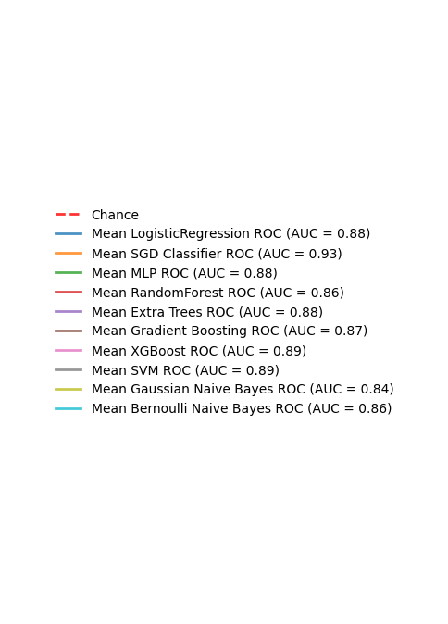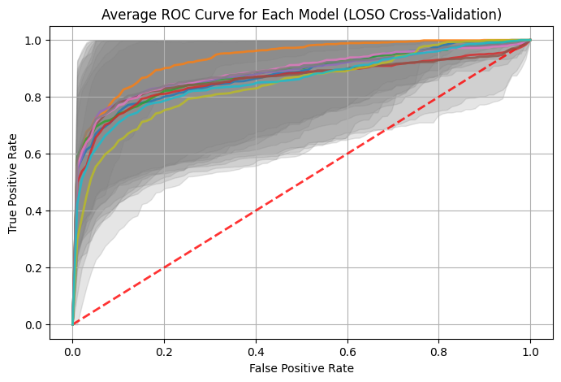

Figure ‑: Average Receiver Operating Characteristic (ROC) Curve for Each Model (LOSO Cross-Validation). This plot displays the mean true positive rate versus false positive rate for various classifiers, with the shaded regions indicating the standard deviation of ROC curves across individual subject folds, providing insight into model robustness and generalization capabilities.

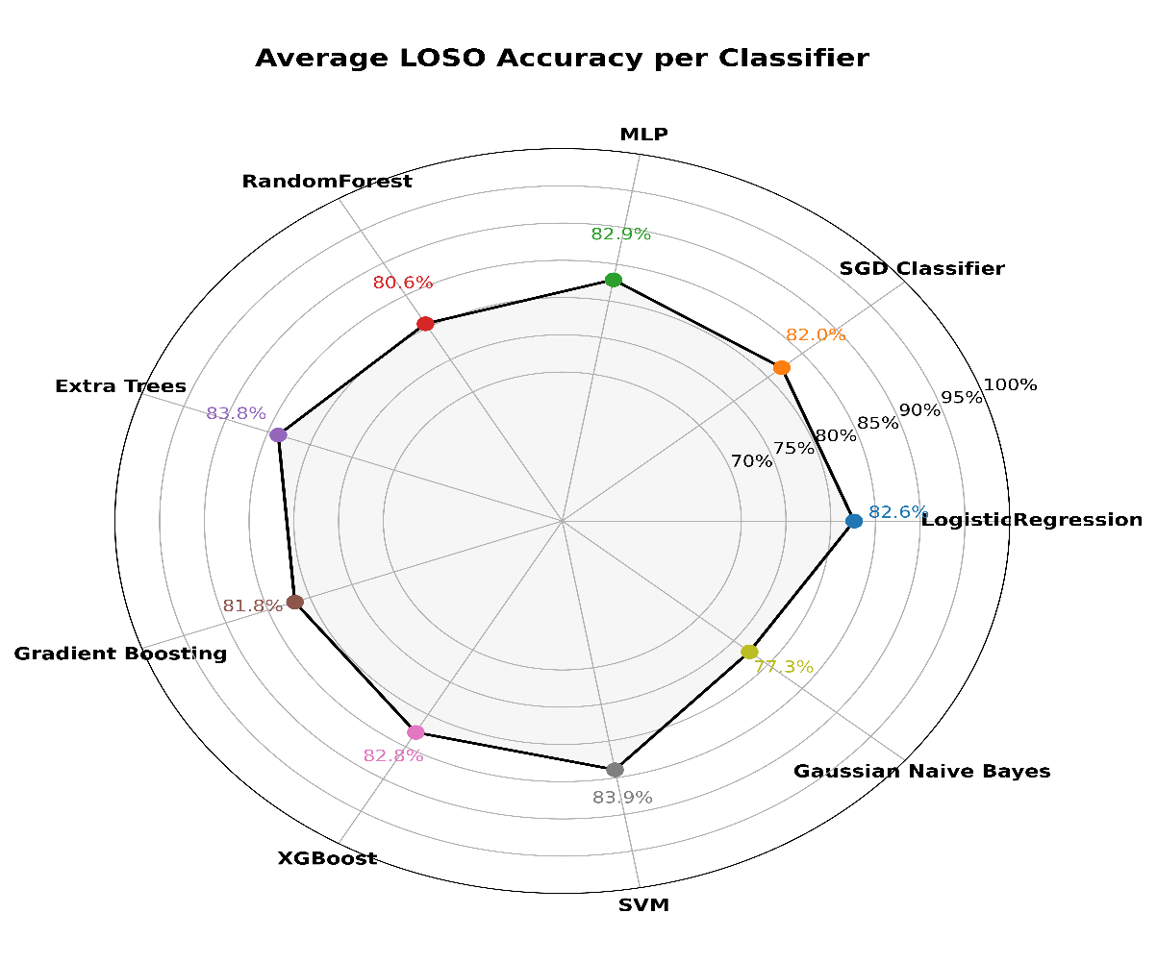

Figure ‑: Radar plot showing average LOSO accuracy (%) for each classifier, illustrating model performance across subjects.

### Comparison with Existing Literature

Our framework achieves state-of-the-art performance in EEG-based attention classification (Table 5-3). For subject-dependent tasks, it attains 98–99% (±~1%) accuracy (stratified 2-fold CV), surpassing Nuamah & Seong (2021) (93.33%) and Chen et al. (2020) (85.05%), demonstrating the strength of graph-based features (COH, DPLI, MI, r). In subject-independent (LOSO) validation, accuracy reaches 80–84%, matching Chen et al. (2020) (81.60%) with lower variance. While Al-Nafjan & Aldayel (2022) report 96% (holdout), their 5-fold CV drops to 87%, highlighting our method’s stability. Wan et al. (2021) achieve 95.36% for binary classification but degrade with multi-class tasks, whereas our approach remains robust.

Table ‎5‑3:Summary of attention classification performance, demonstrating superior accuracy of the proposed method under rigorous validation (k-fold CV and LOSO) compared to prior work.

|  |  |  |  |
| --- | --- | --- | --- |
| **Authors** | **Method** | **Validation** | **Accuracy %** |
| Nuamah & Seong (2021) | Power bands ratio  SVM | k-fold CV  subject dependent | 93.33% ± 8.16% |
| Chen et al. (2023) | feature fusion time, frequency domains and nonlinear features.  RE, DT, SVM | 5-fold CV  subject dependent  LOSO | CV=85.5%  LOSO=81,6% |
| Al-Nafjan & Aldayel (2022) | PSD features  KNN, SVM, RF | Holdout / 5-fold CV | |  | | --- | | 96% (Holdout), 87% (5-fold) |  |  | | --- | |  | |
| Wan et al. (2021) | Frequency and entropy features  XGBoost | |  | | --- | |  |  |  | | --- | | 5-fold cross-validation  LOSO | | 95.36% ± 2.31%, (CV)  76.30 ± 9.24, (LOSO) |
| Our work | Graph features derived from COH, DPLI, MI, r  ML models | 2-fold CV  LOSO | 98–99% ±1%, (CV)  80–84% ± 15–17%, (LOSO) |

The results definitively show that graph-theoretical EEG features effectively differentiate attentive and inattentive states, revealing critical brain network reconfigurations like increased global efficiency. Our developed framework achieved exceptional subject-dependent classification (97-99% accuracy) and robust subject-independent performance (80-84% accuracy). This demonstrates superior generalization capabilities compared to existing literature. The findings underscore the efficacy of our approach for advanced, real-time attention monitoring, providing significant advancements in understanding and applying EEG-based functional connectivity for cognitive state assessment.

# Project Management

## Gantt Chart

The Gantt chart outlines the timeline of the Final Year Project (FYP) across both phases. The project commenced in October with the search for a suitable supervisor, followed by the submission of the proposal in early November. Initial report writing began with an extensive literature search and critical reading of relevant studies, leading into the literature review phase throughout December. The problem statement was finalized in early January, setting the foundation for designing the project’s methodology. Implementation of the methodology began in March 2025, starting with EEG data acquisition and preprocessing. This was followed by analysis, model development, and iterative refinement, culminating in the submission of the final report in June. This structured and phased timeline facilitated a disciplined and efficient workflow throughout the duration of the project.

Table ‎6‑1:Project Gant Chart FYP 1



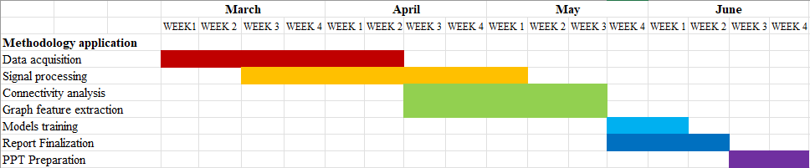Table ‎6‑2: Project Gant Chart FYP 2

## SWOT analysis

This project showcased strong methodological rigor through the integration of multiple connectivity measures (COH, DPLI, MI, Pearson) and a hybrid feature extraction approach combining static and dynamic graph features. The use of both subject-dependent and subject-independent classification pipelines enhanced the comprehensiveness of the evaluation.

However, data quality issues during EEG acquisition and technical limitations within the MNE-Python library introduced complexity and required significant manual processing. Despite these challenges, he promising classification results suggest strong potential for real-time applications in educational and clinical settings. With further development, this approach could be extended to track cognitive states such as fatigue or engagement in real-world environments.

Additionally, the use of graph-based features creates opportunities for integration with network neuroscience research and advanced brain-computer interface (BCI) systems. Nevertheless, the limited number of subjects and the inherent sensitivity of EEG signals to noise present threats to scalability and real-world deployment, highlighting the need for further validation and robust implementation strategies.

In conclusion, this chapter highlighted the structured planning and execution that underpinned the successful progression of the project. The Gantt chart provided a detailed roadmap from initial planning and proposal development to data acquisition, analysis, and final reporting. Adhering to this timeline ensured efficient resource allocation and allowed for timely resolution of technical and methodological challenges.

Through the SWOT analysis, both the strengths and limitations of the project were critically assessed. The robustness of the analytical framework and the effectiveness of the classification models were key strengths, while challenges in data quality and tool limitations underscored areas for improvement. Opportunities for real-world application and research expansion further affirmed the project’s relevance, though attention must be given to mitigating generalizability and implementation risks.

Overall, strong project management practices enabled systematic progress and contributed significantly to the project’s successful completion.

# Conclusions and Future Works

This chapter presents the overall conclusions of the study, discusses its limitations, and outlines promising directions for future work. It begins by summarizing the methodology and findings, followed by a discussion of theoretical and practical implications. The chapter concludes with specific recommendations and a reflection on how this research contributes to the broader field of cognitive state monitoring.

## Summary of the Study

This research developed a graph signal processing-based framework for EEG-based attention detection. EEG recordings were collected from subjects under two distinct cognitive states: attention (induced by watching a lecture video) and inattention (induced by a silent nature scene). Functional connectivity was computed using four measures Coherence (COH), Directed Phase Lag Index (DPLI), Mutual Information (MI), and Pearson correlation to construct networks of neural interactions. From these, both static and dynamic graph-theoretic features were extracted to characterize the spatial and temporal topology of brain networks. These features were then classified using a variety of machine learning models in both subject-dependent and subject-independent paradigms.

## Conclusions

The findings of this study strongly support the hypothesis that EEG-derived graph-based features can effectively distinguish between attentional and inattentional brain states. Subject-dependent classification results demonstrated exceptionally high performance, with models achieving average accuracies above 98% and near-perfect ROC AUC scores. Subject-independent models, evaluated using a rigorous leave-one-subject-out (LOSO) protocol, also showed robust generalization with accuracies ranging between ~77% and ~84% outperformed existing state-of-the-art methods.

Importantly, this study demonstrates that the extracted graph features especially those capturing network integration, segregation, efficiency, and temporal variability can serve as **reliable biomarkers of attention.** These biomarkers capture consistent and interpretable topological patterns: for instance, attention was characterized by efficient, hub-driven, sparse networks, whereas inattention was marked by denser, less efficient, and more fragmented connectivity patterns.

## Limitations

While the results are promising, the study has certain limitations. First, the dataset size was modest, with a limited number of subjects and trials, which may affect generalizability. Although LOSO cross-validation partially addresses this concern, future studies should include a broader participant base. Second, the EEG data were collected using an 8-channel system, which limits spatial resolution and coverage of brain activity. While sufficient for detecting general network dynamics, high-density EEG (e.g., 16 or 32 channels) could provide more detailed topological information and improve feature extraction, particularly for source-space analysis or regional connectivity studies. Third, technical limitations in the MNE-Python library necessitated a manual nested-loop implementation to compute epoch-wise connectivity, increasing the complexity and runtime of the analysis. Lastly, despite preprocessing, EEG signals remained susceptible to noise and artifacts, which may have influenced some extracted features.

## Recommendations and Future Work

Future research should focus on increasing the number and diversity of participants to enhance the generalizability and statistical robustness of the proposed attention detection framework. The current study demonstrated promising results using surface-level EEG; however, incorporating source-space reconstruction could offer a more anatomically precise understanding of the functional networks involved in attentional processing, enabling more localized and interpretable biomarkers.

Moreover, further work should explore which brain regions or subnetwork dynamics drive the most significant differences in connectivity metrics (e.g., centrality, modularity) between attention and inattention states. The association between graph metrics and behavioural performance on sustained attention tasks also merits investigation to validate the cognitive relevance of these features.

References

[1] Y. Li, X. Li, M. Ratcliffe, L. Liu, Y. Qi, and Q. Liu, “A real-time EEG-based BCI system for attention recognition in ubiquitous environment,” in *Proceedings of 2011 international workshop on Ubiquitous affective awareness and intelligent interaction*, in UAAII ’11. New York, NY, USA: Association for Computing Machinery, Sep. 2011, pp. 33–40. doi: 10.1145/2030092.2030099.

[2] Z. Wan, J. He, and A. Voisine, “An Attention Level Monitoring and Alarming System for the Driver Fatigue in the Pervasive Environment,” in *Brain and Health Informatics*, vol. 8211, K. Imamura, S. Usui, T. Shirao, T. Kasamatsu, L. Schwabe, and N. Zhong, Eds., in Lecture Notes in Computer Science, vol. 8211. , Cham: Springer International Publishing, 2013, pp. 287–296. doi: 10.1007/978-3-319-02753-1_29.

[3] M. Arns, C. K. Conners, and H. C. Kraemer, “A decade of EEG Theta/Beta Ratio Research in ADHD: a meta-analysis,” *J Atten Disord*, vol. 17, no. 5, pp. 374–383, Jul. 2013, doi: 10.1177/1087054712460087.

[4] “Attention - Neurophysiology, Perception, Focus | Britannica.” Accessed: Nov. 27, 2024. [Online]. Available: https://www.britannica.com/science/attention

[5] G. W. Lindsay, “Attention in Psychology, Neuroscience, and Machine Learning,” *Front. Comput. Neurosci.*, vol. 14, Apr. 2020, doi: 10.3389/fncom.2020.00029.

[6] “Attention in Psychology | Overview, Types & Examples - Lesson,” study.com. Accessed: Nov. 27, 2024. [Online]. Available: https://study.com/academy/lesson/attention-as-part-of-cognitive-development-definition-process.html

[7] R. C. by S. Nature, “What do we know about student attention in the classroom?,” Research Communities by Springer Nature. Accessed: Nov. 27, 2024. [Online]. Available: http://npjscilearncommunity.nature.com/posts/what-do-we-know-about-student-attention-in-the-classroom

[8] J. K. Grammer, K. Xu, and A. Lenartowicz, “Effects of context on the neural correlates of attention in a college classroom,” *npj Sci. Learn.*, vol. 6, no. 1, pp. 1–4, Jul. 2021, doi: 10.1038/s41539-021-00094-8.

[9] T. J. Buschman and S. Kastner, “From behavior to neural dynamics: An integrated theory of attention,” *Neuron*, vol. 88, no. 1, pp. 127–144, Oct. 2015, doi: 10.1016/j.neuron.2015.09.017.

[10] S. E. Petersen and M. I. Posner, “The Attention System of the Human Brain: 20 Years After,” *Annu Rev Neurosci*, vol. 35, pp. 73–89, Jul. 2012, doi: 10.1146/annurev-neuro-062111-150525.

[11] M. H. Johnson, M. I. Posner, and M. K. Rothbart, “Components of visual orienting in early infancy: contingency learning, anticipatory looking, and disengaging,” *J Cogn Neurosci*, vol. 3, no. 4, pp. 335–344, 1991, doi: 10.1162/jocn.1991.3.4.335.

[12] J. Lim and D. F. Dinges, “A meta-analysis of the impact of short-term sleep deprivation on cognitive variables,” *Psychol Bull*, vol. 136, no. 3, pp. 375–389, May 2010, doi: 10.1037/a0018883.

[13] J. S. Durmer and D. F. Dinges, “Neurocognitive consequences of sleep deprivation,” *Semin Neurol*, vol. 25, no. 1, pp. 117–129, Mar. 2005, doi: 10.1055/s-2005-867080.

[14] M. W. Eysenck, N. Derakshan, R. Santos, and M. G. Calvo, “Anxiety and cognitive performance: attentional control theory,” *Emotion*, vol. 7, no. 2, pp. 336–353, May 2007, doi: 10.1037/1528-3542.7.2.336.

[15] S. Hygge, G. W. Evans, and M. Bullinger, “A prospective study of some effects of aircraft noise on cognitive performance in schoolchildren,” *Psychol Sci*, vol. 13, no. 5, pp. 469–474, Sep. 2002, doi: 10.1111/1467-9280.00483.

[16] S. N. F. S. Husin and Z. Y. H. Harith, “The Performance of Daylight through Various Windows for Residential Buildings,” *Asian Journal of Environment-Behaviour Studies*, vol. 3, no. 6, Art. no. 6, Jan. 2018, doi: 10.21834/aje-bs.v3i6.247.

[17] G. Mark, D. Gudith, and U. Klocke, “The cost of interrupted work: more speed and stress,” in *Proceedings of the SIGCHI Conference on Human Factors in Computing Systems*, Florence Italy: ACM, Apr. 2008, pp. 107–110. doi: 10.1145/1357054.1357072.

[18] T. F. Meijman and G. Mulder, “Psychological aspects of workload,” in *Handbook of work and organizational: Work psychology, Vol. 2, 2nd ed*, in Handbook of work and organizational psychology (2nd ed.). , Hove, England: Psychology Press/Erlbaum (UK) Taylor & Francis, 1998, pp. 5–33.

[19] W. S. Helton and P. N. Russell, “Working memory load and the vigilance decrement,” *Exp Brain Res*, vol. 212, no. 3, pp. 429–437, Jul. 2011, doi: 10.1007/s00221-011-2749-1.

[20] J. Hattie, *Visible learning: a synthesis of over 800 meta-analyses relating to achievement*, Reprinted. London: Routledge, 2010.

[21] P. Barrett, F. Davies, Y. Zhang, and L. Barrett, “The impact of classroom design on pupils’ learning: Final results of a holistic, multi-level analysis,” *Building and Environment*, vol. 89, pp. 118–133, Jul. 2015, doi: 10.1016/j.buildenv.2015.02.013.

[22] K. R. Wentzel, “Peer relationships, motivation, and academic performance at school,” in *Handbook of competence and motivation: Theory and application, 2nd ed*, New York, NY, US: The Guilford Press, 2017, pp. 586–603.

[23] C. F. Mang and L. J. Wardley, “Student Perceptions of Using Tablet Technology in Post-Secondary Classes / Perceptions des étudiants quant à l’utilisation des tablettes électroniques dans les classes universitaires,” *Canadian Journal of Learning and Technology*, vol. 39, no. 4, Art. no. 4, Nov. 2013, doi: 10.21432/T22010.

[24] M. Teplan, “FUNDAMENTALS OF EEG MEASUREMENT,” *MEASUREMENT SCIENCE REVIEW*, vol. 2, 2002.

[25] “Electric Fields of the Brain: The neurophysics of EEG | Oxford Academic.” Accessed: Nov. 27, 2024. [Online]. Available: https://academic.oup.com/book/2998

[26] H. U. Amin, W. Mumtaz, A. R. Subhani, M. N. M. Saad, and A. S. Malik, “Classification of EEG Signals Based on Pattern Recognition Approach,” *Front. Comput. Neurosci.*, vol. 11, Nov. 2017, doi: 10.3389/fncom.2017.00103.

[27] E. Angelakis, S. Stathopoulou, J. L. Frymiare, D. L. Green, J. F. Lubar, and J. Kounios, “EEG neurofeedback: a brief overview and an example of peak alpha frequency training for cognitive enhancement in the elderly,” *Clin Neuropsychol*, vol. 21, no. 1, pp. 110–129, Jan. 2007, doi: 10.1080/13854040600744839.

[28] W. Klimesch, H. Schimke, and G. Pfurtscheller, “Alpha frequency, cognitive load and memory performance,” *Brain Topogr*, vol. 5, no. 3, pp. 241–251, 1993, doi: 10.1007/BF01128991.

[29] N.-H. L. Cheng-Yu Chiang andHsuan-Chin Chu, “Recognizing the Degree of Human Attention Using EEG Signals from Mobile Sensors,” *Sensors*, vol. 13, Aug. 2013, doi: https://doi.org/10.3390/s130810273.

[30] R. Wj and C. Hw, “EEG alpha activity reflects attentional demands, and beta activity reflects emotional and cognitive processes,” *Science (New York, N.Y.)*, vol. 228, no. 4700, May 1985, doi: 10.1126/science.3992243.

[31] M. Gola, M. Magnuski, I. Szumska, and A. Wróbel, “EEG beta band activity is related to attention and attentional deficits in the visual performance of elderly subjects,” *International Journal of Psychophysiology*, vol. 89, no. 3, pp. 334–341, Sep. 2013, doi: 10.1016/j.ijpsycho.2013.05.007.

[32] M. Wöstmann, B. Herrmann, B. Maess, and J. Obleser, “Spatiotemporal dynamics of auditory attention synchronize with speech,” *Proc Natl Acad Sci U S A*, vol. 113, no. 14, pp. 3873–3878, Apr. 2016, doi: 10.1073/pnas.1523357113.

[33] J. Kayser *et al.*, “Behavioral measures of attention and cognitive control during a new auditory working memory paradigm,” *Behav Res*, vol. 52, no. 3, pp. 1161–1174, Jun. 2020, doi: 10.3758/s13428-019-01308-z.

[34] Y. Paloyelis, M. A. Mehta, J. Kuntsi, and P. Asherson, “Functional magnetic resonance imaging in attention deficit hyperactivity disorder (ADHD): a systematic literature review,” *Expert Rev Neurother*, vol. 7, no. 10, pp. 1337–1356, Oct. 2007, doi: 10.1586/14737175.7.10.1337.

[35] M.-P. Hosseini, A. Hosseini, and K. Ahi, “A Review on Machine Learning for EEG Signal Processing in Bioengineering,” *IEEE Rev. Biomed. Eng.*, vol. 14, pp. 204–218, 2021, doi: 10.1109/RBME.2020.2969915.

[36] T. K. Vashishth, V. Sharma, K. K. Sharma, B. Kumar, S. Chaudhary, and R. Panwar, “Chapter 10 Enhancing biomedical signal processing with machine learning: A comprehensive review,” in *Digital Transformation in Healthcare 5.0: Volume 1: IoT, AI and Digital Twin*, R. Malviya, S. Sundram, R. Kumar Dhanaraj, and S. Kadry, Eds., De Gruyter, 2024, pp. 277–306. doi: 10.1515/9783111327853-010.

[37] Q. Wang, X. Zhao, J. Huang, Y. Feng, J. Su, and Z. Luo, “Addressing Complexities of Machine Learning in Big Data: Principles, Trends and Challenges from Systematical Perspective,” 2017. doi: 10.20944/preprints201710.0076.v2.

[38] M. Naegelin *et al.*, “An interpretable machine learning approach to multimodal stress detection in a simulated office environment,” *Journal of Biomedical Informatics*, vol. 139, p. 104299, Mar. 2023, doi: 10.1016/j.jbi.2023.104299.

[39] X. Li, B. Hu, Q. Dong, W. Campbell, P. Moore, and H. Peng, “EEG-based attention recognition,” in *2011 6th International Conference on Pervasive Computing and Applications*, Oct. 2011, pp. 196–201. doi: 10.1109/ICPCA.2011.6106504.

[40] N.-H. Liu, C.-Y. Chiang, and H.-C. Chu, “Recognizing the Degree of Human Attention Using EEG Signals from Mobile Sensors,” *Sensors (Basel)*, vol. 13, no. 8, pp. 10273–10286, Aug. 2013, doi: 10.3390/s130810273.

[41] M. A. Sepideh Hajipour Sardouie, “Detection of Human Attention Using EEG Signals,” *IEEE*, Aug. 2018, doi: 10.1109/ICBME.2017.8430244.

[42] J. K. Nuamah and Y. Seong, “Support vector machine (SVM) classification of cognitive tasks based on electroencephalography (EEG) engagement index,” *Brain-Computer Interfaces*, vol. 5, no. 1, pp. 1–12, Jan. 2018, doi: 10.1080/2326263X.2017.1338012.

[43] A. Al-Nafjan and M. Aldayel, “Predict Students’ Attention in Online Learning Using EEG Data,” *Sustainability*, vol. 14, no. 11, Art. no. 11, Jan. 2022, doi: 10.3390/su14116553.

[44] Ç. İ. Acı, M. Kaya, and Y. Mishchenko, “Distinguishing mental attention states of humans via an EEG-based passive BCI using machine learning methods,” *Expert Systems with Applications*, vol. 134, pp. 153–166, Nov. 2019, doi: 10.1016/j.eswa.2019.05.057.

[45] Y. Ke, L. Chen, and L. Fu, “Visual Attention Recognition Based on Nonlinear Dynamical Parameters of EEG,” *Bio-Medical Materials and Engineering*, vol. 24, no. Frontiers in Biomedical Engineering and Biotechnology – Proceedings of the 2nd International Conference on Biomedical Engineering and Biotechnology, 11–13 October 2013, Wuhan, China, pp. 349–355, 2014, doi: 10.3233/BME-130817.

[46] S. M. Pincus, “Approximate entropy as a measure of system complexity.,” *Proceedings of the National Academy of Sciences*, vol. 88, no. 6, pp. 2297–2301, Mar. 1991, doi: 10.1073/pnas.88.6.2297.

[47] W. Wan, X. Cui, Z. Gao, and Z. Gu, “Frontal EEG-Based Multi-Level Attention States Recognition Using Dynamical Complexity and Extreme Gradient Boosting,” *Front. Hum. Neurosci.*, vol. 15, Jun. 2021, doi: 10.3389/fnhum.2021.673955.

[48] C. Chen, J. Wang, and C. Yu, “Assessing the attention levels of students by using a novel attention aware system based on brainwave signals,” *Brit J Educational Tech*, vol. 48, no. 2, pp. 348–369, Mar. 2017, doi: 10.1111/bjet.12359.

[49] B. Hu, X. Li, S. Sun, and M. Ratcliffe, “Attention Recognition in EEG-Based Affective Learning Research Using CFS+KNN Algorithm,” *IEEE/ACM Transactions on Computational Biology and Bioinformatics*, vol. 15, no. 1, pp. 38–45, Jan. 2018, doi: 10.1109/TCBB.2016.2616395.

[50] E. C. Djamal, D. P. Pangestu, and D. A. Dewi, “EEG-based recognition of attention state using wavelet and support vector machine,” in *2016 International Seminar on Intelligent Technology and Its Applications (ISITIA)*, Jul. 2016, pp. 139–144. doi: 10.1109/ISITIA.2016.7828648.

[51] M. Benedek, R. J. Schickel, E. Jauk, A. Fink, and A. C. Neubauer, “Alpha power increases in right parietal cortex reflects focused internal attention,” *Neuropsychologia*, vol. 56, no. 100, pp. 393–400, Apr. 2014, doi: 10.1016/j.neuropsychologia.2014.02.010.

[52] C.-M. Chen and S.-H. Huang, “Web-based reading annotation system with an attention-based self-regulated learning mechanism for promoting reading performance,” *British Journal of Educational Technology*, vol. 45, no. 5, pp. 959–980, 2014, doi: 10.1111/bjet.12119.

[53] S. Parui, D. Basu, W. Mansoor, and U. Ghosh, “Artificial Intelligence Induced Multi -Level Attention States Recognition from Brain using EEG Signal,” in *2021 4th International Conference on Signal Processing and Information Security (ICSPIS)*, Nov. 2021, pp. 1–4. doi: 10.1109/ICSPIS53734.2021.9652419.

[54] C.-J. Peng, Y.-C. Chen, C.-C. Chen, S.-J. Chen, B. Cagneau, and L. Chassagne, “An EEG-Based Attentiveness Recognition System Using Hilbert–Huang Transform and Support Vector Machine,” *J. Med. Biol. Eng.*, vol. 40, no. 2, pp. 230–238, Apr. 2020, doi: 10.1007/s40846-019-00500-y.

[55] X. Xu, X. Nie, J. Zhang, and T. Xu, “Multi-Level Attention Recognition of EEG Based on Feature Selection,” *Int J Environ Res Public Health*, vol. 20, no. 4, p. 3487, Feb. 2023, doi: 10.3390/ijerph20043487.

[56] D. Chen, H. Huang, X. Bao, J. Pan, and Y. Li, “An EEG-based attention recognition method: fusion of time domain, frequency domain, and non-linear dynamics features,” *Front. Neurosci.*, vol. 17, Jul. 2023, doi: 10.3389/fnins.2023.1194554.

[57] B. Hamadicharef *et al.*, “Learning EEG-based spectral-spatial patterns for attention level measurement,” in *2009 IEEE International Symposium on Circuits and Systems (ISCAS)*, May 2009, pp. 1465–1468. doi: 10.1109/ISCAS.2009.5118043.

[58] M. Mohammadpour and S. Mozaffari, “Classification of EEG-based attention for brain computer interface,” in *2017 3rd Iranian Conference on Intelligent Systems and Signal Processing (ICSPIS)*, Shahrood: IEEE, Dec. 2017, pp. 34–37. doi: 10.1109/ICSPIS.2017.8311585.

[59] K. Lee, K.-M. Choi, S. Park, S.-H. Lee, and C.-H. Im, “Selection of the optimal channel configuration for implementing wearable EEG devices for the diagnosis of mild cognitive impairment,” *Alzheimer’s Research & Therapy*, vol. 14, no. 1, p. 170, Nov. 2022, doi: 10.1186/s13195-022-01115-3.

[60] M. Arns, J. Gunkelman, M. Breteler, and D. Spronk, “EEG phenotypes predict treatment outcome to stimulants in children with ADHD,” *J Integr Neurosci*, vol. 7, no. 3, pp. 421–438, Sep. 2008, doi: 10.1142/s0219635208001897.

[61] V. Ushakov, M. G. Sharaev, S. I. Kartashov, V. V. Zavyalova, V. M. Verkhlyutov, and B. M. Velichkovsky, “Dynamic Causal Modeling of Hippocampal Links within the Human Default Mode Network: Lateralization and Computational Stability of Effective Connections,” *Front. Hum. Neurosci.*, vol. 10, Oct. 2016, doi: 10.3389/fnhum.2016.00528.

[62] S. Grover, J. A. Nguyen, and R. M. G. Reinhart, “Synchronizing Brain Rhythms to Improve Cognition,” *Annu Rev Med*, vol. 72, pp. 29–43, Jan. 2021, doi: 10.1146/annurev-med-060619-022857.

[63] P. Krukow and K. Jonak, “Relationships between resting-state EEG functional networks organization and individual differences in mind wandering,” *Sci Rep*, vol. 12, no. 1, p. 21224, Dec. 2022, doi: 10.1038/s41598-022-25851-6.

[64] U. Braun *et al.*, “Dynamic reconfiguration of frontal brain networks during executive cognition in humans,” *Proc Natl Acad Sci U S A*, vol. 112, no. 37, pp. 11678–11683, Sep. 2015, doi: 10.1073/pnas.1422487112.

[65] M. D. Rosenberg *et al.*, “Functional connectivity predicts changes in attention observed across minutes, days, and months,” *Proc Natl Acad Sci U S A*, vol. 117, no. 7, pp. 3797–3807, Feb. 2020, doi: 10.1073/pnas.1912226117.

[66] M. Rubinov and O. Sporns, “Complex network measures of brain connectivity: uses and interpretations,” *Neuroimage*, vol. 52, no. 3, pp. 1059–1069, Sep. 2010, doi: 10.1016/j.neuroimage.2009.10.003.

[67] J. M. Shine *et al.*, “The Dynamics of Functional Brain Networks: Integrated Network States during Cognitive Task Performance,” *Neuron*, vol. 92, no. 2, pp. 544–554, Oct. 2016, doi: 10.1016/j.neuron.2016.09.018.

[68] S. M. Smith *et al.*, “A positive-negative mode of population covariation links brain connectivity, demographics and behavior,” *Nat Neurosci*, vol. 18, no. 11, pp. 1565–1567, Nov. 2015, doi: 10.1038/nn.4125.

[69] D. S. Bassett and E. T. Bullmore, “Small-World Brain Networks Revisited,” *Neuroscientist*, vol. 23, no. 5, pp. 499–516, Oct. 2017, doi: 10.1177/1073858416667720.

[70] C. Gratton *et al.*, “Functional Brain Networks Are Dominated by Stable Group and Individual Factors, Not Cognitive or Daily Variation,” *Neuron*, vol. 98, no. 2, pp. 439-452.e5, Apr. 2018, doi: 10.1016/j.neuron.2018.03.035.

[71] A. Zalesky, A. Fornito, L. Cocchi, L. L. Gollo, and M. Breakspear, “Time-resolved resting-state brain networks,” *Proc Natl Acad Sci U S A*, vol. 111, no. 28, pp. 10341–10346, Jul. 2014, doi: 10.1073/pnas.1400181111.

[72] B. Mišić, O. Sporns, and A. R. McIntosh, “Communication efficiency and congestion of signal traffic in large-scale brain networks,” *PLoS Comput Biol*, vol. 10, no. 1, p. e1003427, Jan. 2014, doi: 10.1371/journal.pcbi.1003427.

[73] M.-E. Lynall *et al.*, “Functional Connectivity and Brain Networks in Schizophrenia,” *J Neurosci*, vol. 30, no. 28, pp. 9477–9487, Jul. 2010, doi: 10.1523/JNEUROSCI.0333-10.2010.

[74] S. Gu *et al.*, “Controllability of structural brain networks,” *Nat Commun*, vol. 6, no. 1, p. 8414, Oct. 2015, doi: 10.1038/ncomms9414.

[75] G. Deco, D. Vidaurre, and M. L. Kringelbach, “Revisiting the global workspace orchestrating the hierarchical organization of the human brain,” *Nat Hum Behav*, vol. 5, no. 4, pp. 497–511, Apr. 2021, doi: 10.1038/s41562-020-01003-6.

[76] J. D. Power, B. L. Schlaggar, C. N. Lessov-Schlaggar, and S. E. Petersen, “Evidence for hubs in human functional brain networks,” *Neuron*, vol. 79, no. 4, pp. 798–813, Aug. 2013, doi: 10.1016/j.neuron.2013.07.035.

[77] B. A. Olshausen and D. J. Field, “Sparse coding of sensory inputs,” *Curr Opin Neurobiol*, vol. 14, no. 4, pp. 481–487, Aug. 2004, doi: 10.1016/j.conb.2004.07.007.

Appendices

Appendix A

**Graph features description**

Static Graph Features (37 Features) referenced in Chapter 4, Section 4.6

Table A‑1:Basic Topology, Path Efficiency, and Centrality Features

|  |  |  |
| --- | --- | --- |
| **Feature Type** | **Name** | **Description** |
|  | Number of nodes | Total number of EEG channels (nodes) in the graph. |
| **Basic Topology** | Number of edges | Total number of connections (edges) between channels. |
|  | Density | Ratio of existing edges to possible edges (measures sparsity). |
|  | Total weight | Sum of all edge weights (absolute coherence values). |
|  | Average weight | Mean edge weight across the graph. |
| **Weight Statistics** | Minimum weight | Minimum edge weight in the graph. |
|  | Maximum weight | Maximum edge weight in the graph |
|  | Std weight | Standard deviation of edge weights. |
|  | characteristic path length | Average shortest path length between all node pairs. |
| **Path Efficiency** | Global efficiency | Mean inverse shortest path length (integration efficiency). |
|  | Diameter | Longest shortest path in the graph (network robustness). |
| **Clustering** | Average clustering weighted | Mean weighted clustering coefficient (local connectivity density). |
|  | Transitivity | Ratio of triangles to triplets (global redundancy). |
|  | Average degree centrality | Mean normalized degree of nodes (hub dominance). |
| **Centrality** | Average betweenness centrality | Mean fraction of shortest paths passing through each node (bottlenecks). |
|  | Average closeness centrality | Mean inverse sum of shortest paths to all other nodes (information flow). |
| **Degree** | Assortativity degree | Correlation coefficient of degrees between connected nodes. |
|  | Average weighted degree | Mean sum of edge weights per node. |

Table A‑2:Community, Spectral, Robustness, and Statistical Features

|  |  |  |
| --- | --- | --- |
| **Feature Type** | **Name** | **Description** |
|  | Modularity | Strength of network division into communities (Louvain algorithm). |
| **Community Structure** | Number of communities | Number of detected functional modules. |
|  | Max community size | Size of the largest community. |
| **Spectral Metrics** | Spectral radius | Largest eigenvalue of the adjacency matrix (synchronizability). |
|  | Algebraic connectivity | Second-smallest eigenvalue of Laplacian (graph connectivity strength). |
| **Component Analysis** | Number of connected components | Number of isolated subgraphs. |
|  | Size of largest component ratio | Ratio of nodes in the largest connected component to total nodes. |
| **Statistical** | Gini coefficient degree | Inequality in degree distribution (0 = uniform, 1 = maximal inequality). |
|  | Entropy degree | Shannon entropy of degree distribution (randomness in connectivity). |
|  | Average eccentricity | Mean maximum shortest path length from each node to others. |
| **Node Roles** | Periphery nodes ratio | Fraction of nodes with eccentricity equal to the graph diameter. |
|  | Centre nodes ratio | Fraction of nodes with minimal eccentricity. |
| **Core Structure** | Average _k core size | Mean size of the largest k-core across all nodes. |
|  | Max k core size | Size of the maximal k-core (tightly interconnected subgroup). |
| **Robustness** | Node connectivity | Minimum nodes to remove to disconnect the graph. |
|  | Edge connectivity | Minimum edges to remove to disconnect the graph. |
| **Unweighted** | Average shortest path unweighted | Average shortest path length (ignoring edge weights). |
|  | Average degree unweighted | Mean degree of nodes (unweighted graph). |

Dynamic Graph Features (7 Features), referenced in Chapter 4, Section 4.6)

Table A‑3:Temporal Network Dynamics

|  |  |  |
| --- | --- | --- |
| **Feature Type** | **Name** | **Description** |
| **Weight Variability** | Current epoch edge weight variability | Standard deviation of edge weights within an epoch. |
|  | Current epoch mean edge weight | Mean edge weight of the current epoch. |
| **Topological Change** | Reconfiguration jaccard index | Overlap in edges between consecutive epochs (temporal stability). |
|  | Frobenius norm diff | Magnitude of connectivity matrix changes between epochs. |
| **Local Dynamics** | Delta mean degree | Change in average node degree between epochs. |
|  | Delta mean clustering | Change in mean clustering coefficient between epochs. |
| **Strong Connections** | Current epoch strong connections count | Number of edges exceeding a threshold (e.g., top 20% weights). |

Appendix B

****Specifications of the Enobio 8 Neuroelectric Device****

1. **Device Overview**

The Enobio 8 is a wireless, wearable EEG (electroencephalography) system designed for neuroelectric signal acquisition. It is used for research applications in neuroscience, brain-computer interfaces (BCIs), and cognitive studies.

1. **Key Specifications**

* Channels: 8 active EEG electrodes
* Sampling Rate: Up to 500 Hz (configurable)
* Resolution: 24-bit ADC
* Wireless Connectivity: Bluetooth or USB dongle
* Battery Life: ~8–10 hours (depending on usage)
* -Input Referred Noise: < 1 µVrms
* Bandwidth: 0–125 Hz
* Electrode Type: Dry or wet electrodes (Ag/AgCl)
* Compatibility: Windows, macOS, Linux (via API or software like Neuroelectrics Instrument Controller (NIC))
* Software: NIC for data acquisition, MATLAB/Python SDK for analysis

1. **Electrode Placement (10-20 System)**

The Enobio 8 follows the standard 10-20 EEG placement system. Default electrode positions may include:

* Fp1, Fp2, C3, C4, T7, T8, O1, O2 (or customizable based on the study).

1. **Data Output Formats**

* Raw EEG signals (µV) in. easy, edf, or. mat formats
* Real-time streaming via TCP/IP or Lab Streaming Layer (LSL)

1. Additional Features

* Built-in accelerometer for motion artifact detection
* Event markers for synchronization with external stimuli
* Impedance monitoring in real-time